

|  |  |
| --- | --- |
|  |  |
| **FPT UNIVERSITY** | | |
| Capstone Project Document | | |

**USEFUL JAPANESE DICTIONARY FOR VIETNAMESE**

Software Requirement Specification

Project code: UJD_VN

Document Code: UJD_VN_Software requirerement specification_v1.0_EN

- Hanoi, 06/2014 -

Record of change

*A - Added M - Modified D - Deleted

|  |  |  |  |  |
| --- | --- | --- | --- | --- |
| Effective Date | Changed Items | A* M, D | Change Description | New Version |
| 07/06/2014 | Add new | A |  | v0.1 |
| 14/06/2014 | Change 1.6 functional specification | M | Update functionality follow comments of supervisor | v0.3 |
| 23/06/2014 | Change 1.6 functional specification | M | Update functionality follow comments of supervisor. | v0.6 |
| 30/06/2014 | Change 1.6 functional specification | M | Update functionality follow comments of supervisor. | v1.0 |
| 05/08/2014 | Change 1.5 Entity Relation Model | M | Update model | v1.1 |
|  |  |  |  |  |

**Signature page**

**Riginator** Nguyễn Ngọc Tuấn 23/06/2014

Team member

**Reviewer**  Nguyễn Ngọc Tuấn

Team member

**Approval** Nguyễn Văn Sang

Supervisor

Table of Contents

1.1 Introduction 5

1.1.1 Purposes 5

1.1.2 Definition and Acronyms 5

1.2 System Purpose 5

1.3 Scope 5

1.4 Overall Description 5

1.4.1 System overview 5

1.4.2 Product Features 7

1.4.3 User Characteristics 10

1.4.4 User Documentation 10

1.4.5 Assumption 10

1.5 Entity Relation Model 11

1.5.1 Entity-Relationship Diagram 11

1.5.2 Entity Detail 11

1.6 Functional Specification 22

1.6.1 Common Module 22

1.6.2 Account management Module 31

1.6.3 Contact admin Module 43

1.6.4 Practice management Module 52

1.6.5 Admin’s account management 63

1.6.6 Management Member’s account 70

1.6.7 Vocabulary Management 77

1.6.8 Grammar Management 90

1.6.9 Reading Document Management 101

1.6.10 Conversation management 109

1.6.11 Video Management 122

1.6.12 Listening Article Management 132

1.6.13 Doing test management 144

1.6.14 Contributed content management 156

1.6.15 Contributed opinion management 168

1.7 Non-functional Specification 22

1.7.1 Reliability 174

1.7.2 Performance Requirements 174

1.7.3 User Interface 175

1.7.4 Maintainability 175

1.7.5 Usability 175

1.7.6 Security Requirements 175

1.7.7 Hardware/Software Requirements 176

## Introduction

### Purposes

This document is created as the introduction for project Useful Japanese Dictionary for Vietnamese – our Capstone Project at FPT University. In this document, we will descript the overview of some existing systems, the initial idea for our project, a brief description about our expected system and some potential risks, critical assumptions, constrains. Moreover, this document also shows opportunities what it offers for users.

### Definition and Acronyms

This section describes the definitions, terms, and acronyms that are used in software requirements specification.

|  |  |
| --- | --- |
| Items | Description |
| UJD_VN | Useful Japanese dictionary for Vietnamese |
|  |  |
|  |  |

**Table 3-1: Definition and Acronyms**

## System Purpose

That system is developed to help user easily find out information about Japanese (grammar, vocabulary, etc...) and training skill, doing test.

## Scope

The scope of this project contains Requirement Analysis, Design, Coding and Testing (Unit Test, Integration Test, and System Test).

## Overall Description

### System overview

Nowadays, there are many dictionaries which support Japanese. That can be a website or mobile application. All of them have been created for the purpose of helping users search vocabulary or studying Japanese more easily. But we found some disadvantages which existing in website which support users studying Japanese. So, our project – UJD_VN will include some main functions of existing dictionary website and add some special features such as showing examples by Vietnamese, supporting searching specialized vocabulary or users can contribute idea, good knowledge to make our database become larger. Moreover, we will provide freely website to users. Here, we toward provide website for Vietnamese who want to studying Japanese communication or who want to join Japanese certification exams.

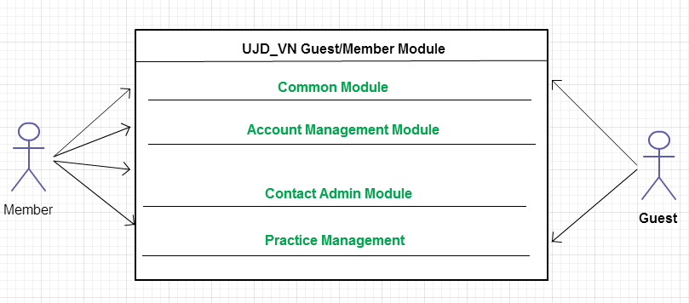

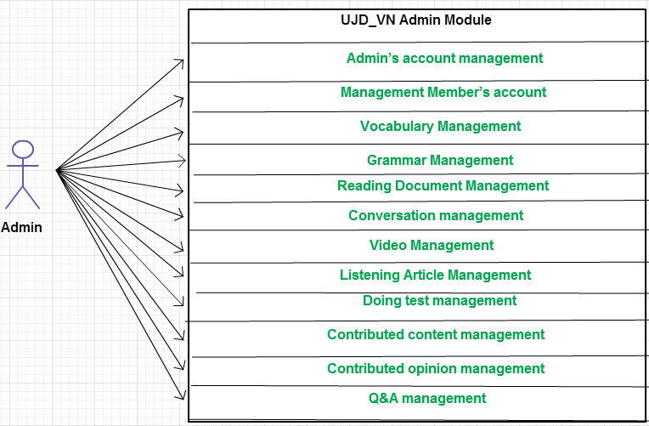

### Product Features

|  |  |  |  |
| --- | --- | --- | --- |
| **Use Case No.** | **Group of functions** | **Functions** | **Glossary** |
| **UJD_VN GUEST/MEMBER MODULE** | | | |
| **Common Module** | | | |
|  | Search | Search sentences | Tìm kiếm các mẫu câu ví dụ |
|  | Search conversation | Tìm kiếm các đoạn hội thoại |
|  | Search grammar | Tìm kiếm ngữ pháp |
|  | Search video | Tìm kiếm Video tiếng Nhật |
|  | Search specialized Japanese | Tìm kiếm Tiếng Nhật chuyền ngành |
| **Account Management Module** | | | |
|  | Login | Login by Facebook account | Đăng nhập bằng tài khoản Facebook |
| Login by Google account | Đăng nhập bằng tài khoản Google |
| Login by registered account | Đăng nhập bằng tài khoản tự đăng kí |
|  |  | Logout | Đăng xuất |
|  |  | Register | Đăng kí tài khoản cho khách để sử dụng nhiều chức năng hơn của website |
|  |  | Edit Profile | Chỉnh sửa thông tin cá nhân |
|  |  | Forgot Password | Quên mật khẩu |
| **Contact Admin Module** | | | |
|  | Contact Admin | Contribute content | Đóng góp database hữu ích cho website |
|  | Contribute opinion | Đóng góp ý kiến để phát triển trang web |
|  | Send Q & A | Gửi câu hỏi thắc mắc trong quá trình sử dụng Website |
| **Practice Management** | | | |
|  | Doing Test | Test | Làm bài kiểm tra trắc nghiệm |
| Tracking mark | Theo dõi quá trình học tập |
|  |  | Training Listening | Luyện Nghe trình độ N2,N3,N4 |
|  |  | Listening conversation | Nghe hội thoại |
|  |  | Reading Document | Đọc tài liệu |
| **UJD_VN ADMIN MODULE** | | | |
|  | Admin’s account management | Add new admin | Thêm mới admin |
|  | Edit profile | Chỉnh sửa thông tin admin |
|  | Delete admin | Xóa thông tin admin |
|  | Management Member’s account | Search member | Tìm kiếm thành viên |
|  | Ban/Unban Member’s account | Khóa/Mở khóa tài khoản thành viên |
|  | Delete member | Xóa thành viên |
|  | Vocabulary Management | Search vocabulary | Tìm kiếm từ vựng |
|  | Add vocabulary | Thêm mới từ vựng |
|  | Edit vocabulary | Chỉnh sửa thông tin từ vựng |
|  | Delete vocabulary | Xóa từ vựng |
|  | Grammar Management | Search grammar | Tìm kiếm ngữ pháp |
|  | Add Grammar | Thêm ngữ pháp mới |
|  | Edit grammar | Chỉnh sửa ngữ pháp |
|  | Delete Grammar | Xóa ngứ pháp |
|  | Reading Document Management | Search reading document | Tìm kiếm các bài đọc |
|  | Add reading document | Thêm mới các bài đọc |
|  | Edit reading document | Chỉnh sửa thông tin các bài đọc |
|  | Delete reading document | Xóa các bài đọc |
|  | Conversation management | Search conversation | Tìm kiếm các bài hội thoại |
|  | Add conversation | Thêm mới bài hội thoại |
|  | Edit conversation | Chỉnh sửa bài hội thoại |
|  | Delete conversation | Xóa bài hội thoại |
|  | Video Management | Search Video | Tìm kiếm Video bằng tiêu đề |
|  | Add Video | Thêm mới video |
|  | Edit Video | Chỉnh sửa nội dung liên quan đến video như tiêu đề. |
|  | Delete Video | Xóa video |
|  | Listening Article Management | Search listening article | Tìm kiếm các bài nghe |
|  | Add listening article | Thêm mới các bài nghe |
|  | Edit listening article | Chỉnh sửa các bài nghe |
|  | Delete listening article | Xóa các bài nghe |
|  | Doing test management | Search test | Tìm kiếm bài kiểm tra |
|  | Add test | Thêm mới bài kiểm tra |
|  | Edit test | Chỉnh sửa bài kiếm tra |
|  | Delete test | Xóa bài kiểm tra |
| **Contact’s Content Management** | | | |
|  | Contributed content management | Search contribute content | Tìm kiếm nội dung đóng góp |
| Approve content | Chấp nhận ý kiến đóng góp |
| Reply user | Trả lời người dùng |
| Delete content | Xóa nội dung đóng góp |
|  | Contributed opinion management | Search contribute opinion | Tìm kiếm ý kiến đóng góp |
| Reply user | Phản hồi lại ý kiến người dùng |
| Delete opinion | Xóa ý kiến đóng góp |
|  | Q & A Management | Search Q & A | Tìm kiếm Q & A |
| Reply Q & A | Trả lời Q & A |
| Delete Q & A | Xóa Q & A |

### User Characteristics

This website developed towards those who have achieved elementary level Japanese and want to improve intermediate level. The website requires users to have the ability to use a browser with an internet connection. Use can easy use the functions in website, but if they want to use all function, they must be login.

### User Documentation

List of document when delivering this application is in the table below:

|  |  |
| --- | --- |
| Name | Description |
| User Manual | Provide detailed explanation about the system, screens and guide users how to use all features of UJD_VN website. |

### Assumption

* Receive the guidance and good support of teacher.
* No one of member got sick in the software development process.
* In the development process, no device got fail.
* Every report meets the deadline.
* Team member do not conflict in the work process.

## Entity Relation Model

### Entity-Relationship Diagram

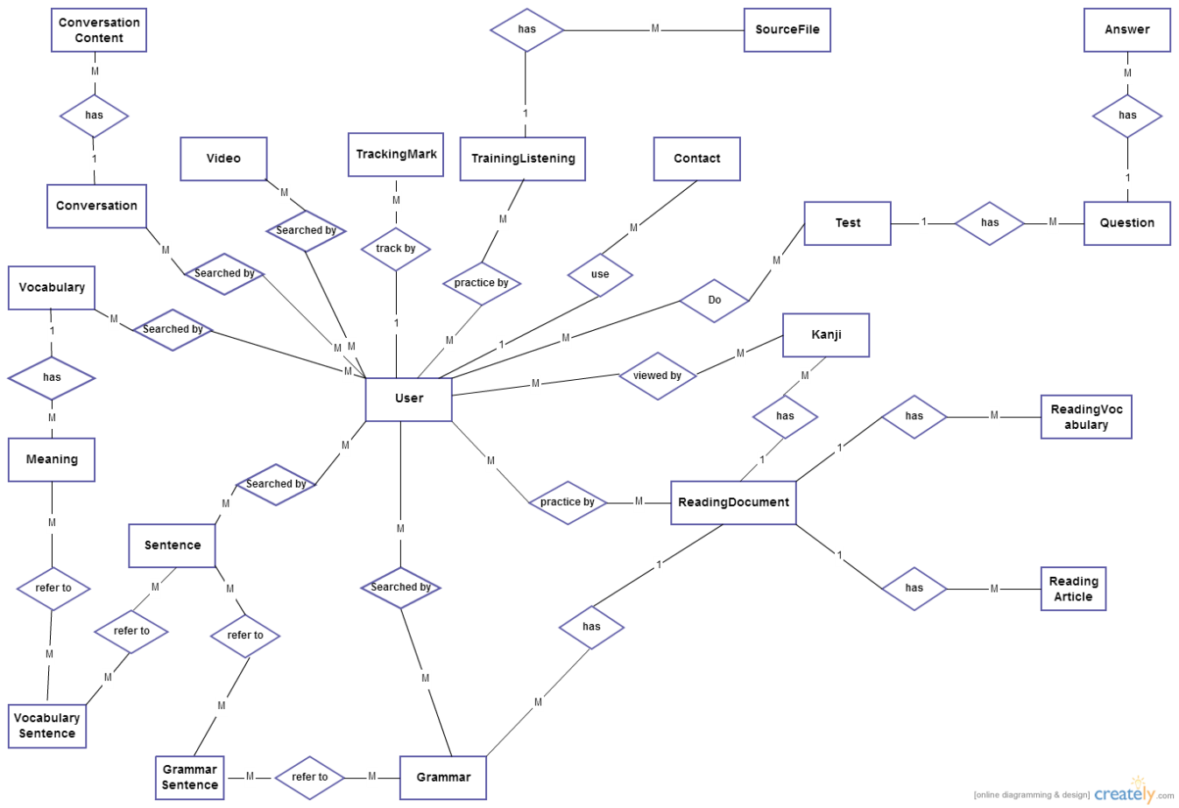

### Entity Detail

#### Vocabulary

|  |  |  |  |  |  |  |  |  |  |
| --- | --- | --- | --- | --- | --- | --- | --- | --- | --- |
| No | Field Name | Type | Length | Size | Null | Unique | P/F Key | Default | Description |
|  | v_id | Int |  |  |  |  | P |  | PRIMARY KEY  This is automatically increase value 1 |
|  | v_hiragana | varchar | 200 |  |  |  |  |  | Vocabulary’s hiragana |
|  | v_romaji | Varchar | 200 |  |  |  |  |  | Vocabulary’s romaji |
|  | v_status | int |  |  |  |  |  |  | Vocabulary’s status |

#### Meaning

|  |  |  |  |  |  |  |  |  |  |
| --- | --- | --- | --- | --- | --- | --- | --- | --- | --- |
| No | Field Name | Type | Length | Size | Null | Unique | P/F Key | Default | Description |
|  | m_id | Int |  |  |  |  | P |  | PRIMARY KEY  This is automatically increase value 1 |
|  | v_id | Int |  |  |  |  | FK |  | Foreign key to Vocabulary |
|  | m_meaningvn | varchar | 500 |  |  |  |  |  | Meaning of vocabulary |
|  | m_category | Varchar | 10 |  |  |  |  |  | Category of vocabulary |
|  | m_kanji | Varchar | 10 |  | Y |  |  |  | Kanji of vocabulary |
|  | m_specialized | varchar | 200 |  |  |  |  |  | Vocabulary’s specialized |

#### Vocabulary sentences

|  |  |  |  |  |  |  |  |  |  |
| --- | --- | --- | --- | --- | --- | --- | --- | --- | --- |
| No | Field Name | Type | Length | Size | Null | Unique | P/F Key | Default | Description |
|  | m_id | Int |  |  |  |  | FK |  | Foreign key to Meaning |
|  | s_id | Int |  |  |  |  | FK |  | Foreign key to Sentence |

#### Sentence

|  |  |  |  |  |  |  |  |  |  |
| --- | --- | --- | --- | --- | --- | --- | --- | --- | --- |
| No | Field Name | Type | Length | Size | Null | Unique | P/F Key | Default | Description |
|  | s_id | Int |  |  |  |  | P |  | PRIMARY KEY  This is automatically increase value 1 |
|  | s_hiragana | varchar | 1000 |  |  |  |  |  | Sentence’s hiragana |
|  | s_romaji | Varchar | 1000 |  |  |  |  |  | Sentence’s romaji |
|  | s_meaning | varchar | 1000 |  |  |  |  |  | Sentence’s meaning |
|  | s_kanji | varchar | 1000 |  |  |  |  |  | Sentence’s kanji |

#### Grammar

|  |  |  |  |  |  |  |  |  |  |
| --- | --- | --- | --- | --- | --- | --- | --- | --- | --- |
| No | Field Name | Type | Length | Size | Null | Unique | P/F Key | Default | Description |
|  | g_id | Int |  |  |  |  | P |  | PRIMARY KEY  This is automatically increase value 1 |
|  | g_hiragana | varchar | 200 |  |  |  |  |  | Grammar’s hiragana |
|  | g_romaji | Varchar | 200 |  |  |  |  |  | Grammar’s romaji |
|  | g_level | Varchar | 10 |  |  |  |  |  | Grammar’s level |
|  | g_meaning | varchar | 200 |  |  |  |  |  | Grammar’s meaning |
|  | g_use | varchar | 1000 |  |  |  |  |  | Grammar’s use |
|  | g_status | int |  |  |  |  |  |  | Grammar’s status |
|  | reading_id | Varchar | 20 |  |  |  | FK |  | Foreign key to ReadingDocument |

#### Grammar sentences

|  |  |  |  |  |  |  |  |  |  |
| --- | --- | --- | --- | --- | --- | --- | --- | --- | --- |
| No | Field Name | Type | Length | Size | Null | Unique | P/F Key | Default | Description |
|  | m_id | Int |  |  |  |  | FK |  | Foreign key to Meaning |
|  | s_id | Int |  |  |  |  | FK |  | Foreign key to Sentence |

#### Video

|  |  |  |  |  |  |  |  |  |  |
| --- | --- | --- | --- | --- | --- | --- | --- | --- | --- |
| No | Field Name | Type | Length | Size | Null | Unique | P/F Key | Default | Description |
|  | vi_id | Int |  |  |  |  | P |  | PRIMARY KEY  This is automatically increase value 1 |
|  | vi_title | varchar | 200 |  |  |  |  |  | Video’s title |
|  | vi_link | varchar | 200 |  |  |  |  |  | Video’s link |

#### Kanji

|  |  |  |  |  |  |  |  |  |  |
| --- | --- | --- | --- | --- | --- | --- | --- | --- | --- |
| No | Field Name | Type | Length | Size | Null | Unique | P/F Key | Default | Description |
|  | k_id | Int |  |  |  |  | P |  | PRIMARY KEY  This is automatically increase value 1 |
|  | k_kanji | varchar | 10 |  |  |  |  |  | Kanji in Japanese |
|  | k_hanviet | varchar | 50 |  |  |  |  |  | Kanji’s Vietnamese-Han |
|  | k_onyomi | varchar | 100 |  |  |  |  |  | Kanji’s onyomi |
|  | k_kunyomi | varchar | 100 |  |  |  |  |  | Kanji’s kunyomi |
|  | k_meaning | varchar | 200 |  |  |  |  |  | Kanji’s meaning |
|  | k_level | varchar | 10 |  |  |  |  |  | Kanji’s level |
|  | k_status | int |  |  |  |  |  |  | Kanji’s status |
|  | reading_id | Varchar | 20 |  |  |  |  |  | Kanji’s readingdocument |

#### Conversation

|  |  |  |  |  |  |  |  |  |  |
| --- | --- | --- | --- | --- | --- | --- | --- | --- | --- |
| No | Field Name | Type | Length | Size | Null | Unique | P/F Key | Default | Description |
|  | c_id | Varchar | 10 |  |  |  | P |  | PRIMARY KEY  This is automatically increase value 1 |
|  | c_level | varchar | 10 |  |  |  |  |  | Conversation’s level |
|  | c_title | varchar | 100 |  |  |  |  |  | Conversation’s title |
| 1. C_ | c_image | Varchar | 200 |  |  |  |  |  | Conversation’s image |

#### Conversation content

|  |  |  |  |  |  |  |  |  |  |
| --- | --- | --- | --- | --- | --- | --- | --- | --- | --- |
| No | Field Name | Type | Length | Size | Null | Unique | P/F Key | Default | Description |
|  | con_id | Int |  |  |  |  | P |  | PRIMARY KEY  This is automatically increase value 1 |
|  | c_id | Varchar | 10 |  |  |  | FK |  | Foreign key to Sentence |
|  | con_title | Varchar | 200 |  |  |  |  |  | Content’s title |
|  | con_hiragana | varchar | 5000 |  |  |  |  |  | Conversation’s hiragana |
|  | con_romaji | Varchar | 5000 |  |  |  |  |  | Conversation’s romaji |
|  | con_meaning | varchar | 5000 |  |  |  |  |  | Conversation’s meaning |
| 1. c | con_file | Varchar | 200 |  |  |  |  |  | File listen of conversation |

#### User

|  |  |  |  |  |  |  |  |  |  |
| --- | --- | --- | --- | --- | --- | --- | --- | --- | --- |
| No | Field Name | Type | Length | Size | Null | Unique | P/F Key | Default | Description |
|  | u_id | Int |  |  |  |  | P |  | PRIMARY KEY  This is automatically increase value 1 |
|  | u_username | Varchar | 32 |  |  | Y |  |  | Username login |
|  | u_password | Varchar | 32 |  |  |  |  |  | Store password login of user.  Using md5 algorithm. |
|  | u_role | int |  |  |  |  |  |  | Admin can assign permission for user |
|  | u_fullname | Varchar | 100 |  |  |  |  |  | User’s name display |
|  | u_email | Varchar | 100 |  |  | Y |  |  | User’s email |
|  | u_registerdate | Date |  |  |  |  |  |  | Date register |
|  | u_status | Int |  |  |  |  |  |  | Active or deactive |

#### Contact

|  |  |  |  |  |  |  |  |  |  |
| --- | --- | --- | --- | --- | --- | --- | --- | --- | --- |
| No | Field Name | Type | Length | Size | Null | Unique | P/F Key | Default | Description |
|  | contact_id | Int |  |  |  |  | P |  | PRIMARY KEY  This is automatically increase value 1 |
|  | contact_email | varchar | 100 |  |  |  |  |  | Contact’s email |
|  | contact_content | varchar | 5000 |  |  |  |  |  | Contact’s content |
|  | contact_type | Varchar | 10 |  |  |  |  |  | Contact’s type |
|  | contact_status | int |  |  |  |  |  |  | Contact’s status |

#### Training Listening

|  |  |  |  |  |  |  |  |  |  |
| --- | --- | --- | --- | --- | --- | --- | --- | --- | --- |
| No | Field Name | Type | Length | Size | Null | Unique | P/F Key | Default | Description |
|  | lis_id | int |  |  |  |  | P |  | PRIMARY KEY  This is automatically increase value 1 |
|  | lis_title | Varchar | 500 |  |  |  |  |  | Listening’s title |
|  | lis_level | varchar | 10 |  |  |  |  |  | Listening’s level |

#### Source file

|  |  |  |  |  |  |  |  |  |  |
| --- | --- | --- | --- | --- | --- | --- | --- | --- | --- |
| No | Field Name | Type | Length | Size | Null | Unique | P/F Key | Default | Description |
|  | sourcefile_id | varchar | 100 |  |  |  | P |  | PRIMARY KEY |
|  | lis_id | Int |  |  |  |  | FK |  | Foreign key to TrainingListening |
|  | sourcefile_ question | varchar | 5000 |  |  |  |  |  | Listen’s question |
|  | sourcefile_ script | varchar | 5000 |  |  |  |  |  | Listen’s script |
|  | sourcefile_ meaning | varchar | 5000 |  |  |  |  |  | Listen’s meaning |
|  | sourcefile_ answer | Varchar | 100 |  |  |  |  |  | Listen’s answer |

#### Reading document

|  |  |  |  |  |  |  |  |  |  |
| --- | --- | --- | --- | --- | --- | --- | --- | --- | --- |
| No | Field Name | Type | Length | Size | Null | Unique | P/F Key | Default | Description |
|  | reading_id | Varchar | 20 |  |  |  | P |  | PRIMARY KEY |
|  | reading_title | varchar | 100 |  |  |  |  |  | Reading’s title |
|  | reading_level | Varchar | 10 |  |  |  |  |  | Reading’s level |

#### Reading vocabulary

|  |  |  |  |  |  |  |  |  |  |
| --- | --- | --- | --- | --- | --- | --- | --- | --- | --- |
| No | Field Name | Type | Length | Size | Null | Unique | P/F Key | Default | Description |
|  | readingvocabulary_id | Int |  |  |  |  | P |  | PRIMARY KEY  This is automatically increase value 1 |
|  | reading_id | Varchar | 20 |  |  |  | FK |  | Foreign key to ReadingDocument |
|  | readingvocabulary_ hiragana | varchar | 100 |  |  |  |  |  | Vocabulary’s hiragana |
|  | readingvocabulary_ meaning | varchar | 100 |  |  |  |  |  | Vocabulary’s meaning |
|  | readingvocabulary_kanji | varchar | 10 |  |  |  |  |  | Vocabulary’s kanji |
|  | readingvocabulary_type | Varchar | 50 |  |  |  |  |  | Type of readingvocabulary |

#### Reading article

|  |  |  |  |  |  |  |  |  |  |
| --- | --- | --- | --- | --- | --- | --- | --- | --- | --- |
| No | Field Name | Type | Length | Size | Null | Unique | P/F Key | Default | Description |
|  | readingarticle_id | Int |  |  |  |  | P |  | PRIMARY KEY  This is automatically increase value 1 |
|  | reading_id | Varchar | 20 |  |  |  | FK |  | Foreign key to ReadingDocument |
|  | readingarticle_content | Varchar | 5000 |  |  |  |  |  | Article’s content |
|  | readingarticle_ question | Varchar | 5000 |  |  |  |  |  | Artcle’s question |
|  | readingarticle_ answer | Varchar | 5000 |  |  |  |  |  | Article’s answer |
|  | readingarticle_mening | Varhar | 5000 |  |  |  |  |  | Translate of article |

#### Tracking mark

|  |  |  |  |  |  |  |  |  |  |
| --- | --- | --- | --- | --- | --- | --- | --- | --- | --- |
| No | Field Name | Type | Length | Size | Null | Unique | P/F Key | Default | Description |
|  | tm_id | Int |  |  |  |  | P |  | PRIMARY KEY  This is automatically increase value 1 |
|  | u_id | Int |  |  |  |  | FK |  | Foreign key to User |
|  | test_id | Varchar | 20 |  |  |  | FK |  | Foreign key to Test |
|  | tm_mark | Int |  |  |  |  |  |  | Test’s mark |
|  | tm_date | Datetime |  |  |  |  |  |  | Test’s date |

#### Test

|  |  |  |  |  |  |  |  |  |  |
| --- | --- | --- | --- | --- | --- | --- | --- | --- | --- |
| No | Field Name | Type | Length | Size | Null | Unique | P/F Key | Default | Description |
|  | test_id | Varchar | 20 |  |  |  | P |  | PRIMARY KEY |
|  | test_ category | varchar | 50 |  |  |  |  |  | Test’s category |
|  | test_level | Varchar | 10 |  |  |  |  |  | Test’s level |
|  | test_content | varchar | 5000 |  |  |  |  |  | Test’s content |

#### Question

|  |  |  |  |  |  |  |  |  |  |
| --- | --- | --- | --- | --- | --- | --- | --- | --- | --- |
| No | Field Name | Type | Length | Size | Null | Unique | P/F Key | Default | Description |
|  | question_id | Int |  |  |  |  | P |  | PRIMARY KEY  This is automatically increase value 1 |
|  | test_id | Varchar | 20 |  |  |  | FK |  | Foreign key to Test |
|  | question_ content | varchar | 200 |  |  |  |  |  | Question’s content |

#### Answer

|  |  |  |  |  |  |  |  |  |  |
| --- | --- | --- | --- | --- | --- | --- | --- | --- | --- |
| No | Field Name | Type | Length | Size | Null | Unique | P/F Key | Default | Description |
|  | answer_id | Int |  |  |  |  | P |  | PRIMARY KEY  This is automatically increase value 1 |
|  | question_id | Int |  |  |  |  | FK |  | Foreign key to Question |
|  | answer_ content | varchar | 200 |  |  |  |  |  | Answer’s content |
|  | answer_ correct | int |  |  |  |  |  |  | Answer’s correct |

## Functional Specification

### Common Module

#### Use Case Diagram

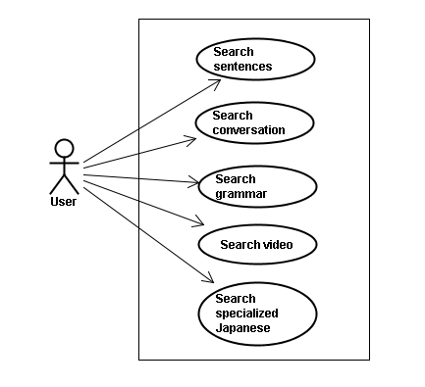

#### Screen description

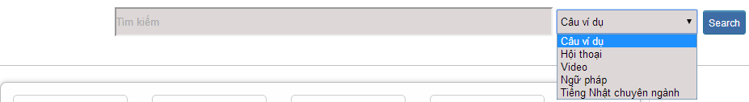

Figure 1: Search

Table 1: Search’s screen description:

|  |  |  |  |  |  |  |  |
| --- | --- | --- | --- | --- | --- | --- | --- |
| No | Field name | Field name in Vietnamese | Type | Require | Mandatory | Length | Description |
| 1 | Searcharea | Tìm kiếm | Text | Text | Y | 255 | User input a new word with length less than 255 characters |
| 2 | SearchOption | Kiểu tìm kiếm | Drop-down list | Click | Y |  | User choose type of search |
| 2 | Search | Search | Button | Click | Y |  | User click on search button |

#### Use Case Specification

##### UC001: <Common module> Search sentences

|  |  |  |  |  |
| --- | --- | --- | --- | --- |
| **UC001 – Search sentences** | | | | |
| **Use-case No.** | <UC001> | **Use-case Version** | | <1.0> |
| **Use-case Name** | Search sentences | | | |
| **Author** | Tuan NN | | | |
| **Date** | 09/06/2014 | **Priority** | <High > | |
| **Actor:**  Guest, Member, Administrator  **Summary:**  When Guest, Member, Administrator want to search by sentences in database successfully if it is existed  **Triggers**  Click on search area , input sentences in the text area, choose type of search and then click “Search” button  **Preconditions:**   * Website is available * User have to input data in search area   **Post Conditions:**  Display detail information of sentences  **Main Success Scenario:**   |  |  |  | | --- | --- | --- | | **Step** | **User** | **System** | | 1 | Enter website link on web browser | Display Home page screen | | 2 | Input data in search area and choose “Câu ví dụ” type then click button Search | Display “sentences information” screen that contains the information of chosen sentences with these elements:   * Serial number * Name of sentences by hiragana * Name of sentences by romaji * Meaning of sentences |     **Alternative Scenario:**   |  |  |  | | --- | --- | --- | | **At Step** | **User** | **System** | | 2 | Input data in search area and choose “Câu ví dụ” type then click on another link | Switch to selected page |   **Exceptions:**   |  |  |  | | --- | --- | --- | | **At Step** | **User** | **System** | | 2 | Fill data that they want to find (that do not exist in database) into these fields then click “Search” button | Return Error message to inorm that sentences cannot be found | | | | | |

##### UC002: <Common module> Search conversation

|  |  |  |  |  |
| --- | --- | --- | --- | --- |
| **UC002 – Search conversation** | | | | |
| **Use-case No.** | <UC002> | **Use-case Version** | | <1.0> |
| **Use-case Name** | Search conversation | | | |
| **Author** | Tuan NN | | | |
| **Date** | 09/06/2014 | **Priority** | <High > | |
| **Actor:**  Guest, Member, Administrator  **Summary:**  When Guest, Member, Administrator want to search by conversation in database successfully if it is existed  **Triggers**  Click on search area , input conversation in the text area, choose type of search and then click “Search” button  **Preconditions:**   * Website is available * User have to input data in search area   **Post Conditions:**  Display detail information of conversation  **Main Success Scenario:**   |  |  |  | | --- | --- | --- | | **Step** | **User** | **System** | | 1 | Enter website link on web browser | Display Home page screen | | 2 | Input data in search area and choose “Hội thoại” type then click button Search | Display “conversation information” screen that contains the information of chosen conversation with these elements:   * Serial number * Name of conversation by hiragana * Name of conversation by romaji * Meaning of conversation |     **Alternative Scenario:**   |  |  |  | | --- | --- | --- | | **At Step** | **User** | **System** | | 2 | Input data in search area and choose “Hội thoại” type then click on another link | Switch to selected page |   **Exceptions:**   |  |  |  | | --- | --- | --- | | **At Step** | **User** | **System** | | 2 | Fill data that they want to find (that do not exist in database) into these fields then click “Search” button | Return Error message to inform that conversation cannot be found | | | | | |

##### UC003: <Common module> Search grammar

|  |  |  |  |  |
| --- | --- | --- | --- | --- |
| **UC003 – Search grammar** | | | | |
| **Use-case No.** | <UC003> | **Use-case Version** | | <1.0> |
| **Use-case Name** | Search grammar | | | |
| **Author** | Tuan NN | | | |
| **Date** | 09/06/2014 | **Priority** | <High > | |
| **Actor:**  Guest, Member, Administrator  **Summary:**  When Guest, Member, Administrator want to search by grammar in database successfully if it is existed  **Triggers**  Click on search area , input grammar in the text area, choose type of search and then click “Search” button  **Preconditions:**   * Website is available * User have to input data in search area   **Post Conditions:**  Display detail information of grammar  **Main Success Scenario:**   |  |  |  | | --- | --- | --- | | **Step** | **User** | **System** | | 1 | Enter website link on web browser | Display Home page screen | | 2 | Input data in search area and choose “Ngữ pháp” type then click button Search | Display “grammar information” screen that contains the information of chosen grammar with these elements:   * Serial number * Name of grammar by hiragana * Name of grammar by romaji * Meaning of grammar |     **Alternative Scenario:**   |  |  |  | | --- | --- | --- | | **At Step** | **User** | **System** | | 2 | Input data in search area and choose “Ngữ pháp” type then click on another link | Switch to selected page |   **Exceptions:**   |  |  |  | | --- | --- | --- | | **At Step** | **User** | **System** | | 2 | Fill data that they want to find (that do not exist in database) into these fields then click “Search” button | Return Error message to inform that grammar cannot be found | | | | | |

##### UC004: <Common module> Search video

|  |  |  |  |  |
| --- | --- | --- | --- | --- |
| **UC004 – Search video** | | | | |
| **Use-case No.** | <UC004> | **Use-case Version** | | <1.0> |
| **Use-case Name** | Search video | | | |
| **Author** | Tuan NN | | | |
| **Date** | 09/06/2014 | **Priority** | <High > | |
| **Actor:**  Guest, Member, Administrator  **Summary:**  When Guest, Member, Administrator want to search by video in database successfully if it is existed  **Triggers**  Click on search area , input video in the text area, choose type of search and then click “Search” button  **Preconditions:**   * Website is available * User have to input data in search area   **Post Conditions:**  Display detail information of video  **Main Success Scenario:**   |  |  |  | | --- | --- | --- | | **Step** | **User** | **System** | | 1 | Enter website link on web browser | Display Home page screen | | 2 | Input data in search area and choose “Video” type then click button Search | Display “video information” screen that contains the information of chosen video with these elements:   * Serial number * Name of video by hiragana * Name of video by romaji * Meaning of video |     **Alternative Scenario:**   |  |  |  | | --- | --- | --- | | **At Step** | **User** | **System** | | 2 | Input data in search area and choose “Video” type then click on another link | Switch to selected page |   **Exceptions:**   |  |  |  | | --- | --- | --- | | **At Step** | **User** | **System** | | 2 | Fill data that they want to find (that do not exist in database) into these fields then click “Search” button | Return Error message to inform that video cannot be found | | | | | |

##### UC005: <Common module> Search specialized Japanese

|  |  |  |  |  |
| --- | --- | --- | --- | --- |
| **UC005 – Search specialized Japanese** | | | | |
| **Use-case No.** | <UC005> | **Use-case Version** | | <1.0> |
| **Use-case Name** | Search specialized Japanese | | | |
| **Author** | Tuan NN | | | |
| **Date** | 09/06/2014 | **Priority** | <High > | |
| **Actor:**  Guest, Member, Administrator  **Summary:**  When Guest, Member, Administrator want to search by specialized Japanese in database successfully if it is existed  **Triggers**  Click on search area , input specialized Japanese in the text area, choose type of search and then click “Search” button  **Preconditions:**   * Website is available * User have to input data in search area   **Post Conditions:**  Display detail information of video  **Main Success Scenario:**   |  |  |  | | --- | --- | --- | | **Step** | **User** | **System** | | 1 | Enter website link on web browser | Display Home page screen | | 2 | Input data in search area and choose “Tiếng Nhật chuyên ngành” type then click button Search | Display “specialized Japanese information” screen that contains the information of chosen specialized Japanese with these elements:   * Serial number * Name of specialized Japanese by hiragana * Name of specialized Japanese by romaji * Meaning of specialized Japanese |     **Alternative Scenario:**   |  |  |  | | --- | --- | --- | | **At Step** | **User** | **System** | | 2 | Input data in search area and choose “Tiếng Nhật chuyên ngành” type then click on another link | Switch to selected page |   **Exceptions:**   |  |  |  | | --- | --- | --- | | **At Step** | **User** | **System** | | 2 | Fill data that they want to find (that do not exist in database) into these fields then click “Search” button | Return Error message to inform that specialized Japanese cannot be found | | | | | |

### Account management Module

#### Use Case Diagram

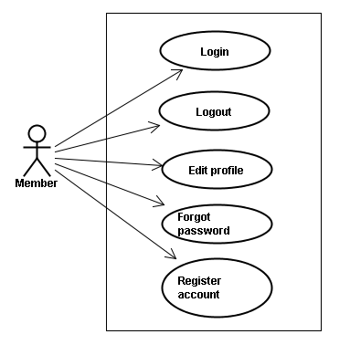

#### Use Case Specification

##### UC006: <Account management module> Login



Figure 2.1: Login

Table 2.1: Login’s screen description:

|  |  |  |  |  |  |  |  |
| --- | --- | --- | --- | --- | --- | --- | --- |
| No | Field name | Field name in Vietnamese | Type | Require | Mandatory | Max-Length | Description |
| 1 | Username | Tên đăng nhập | Text | Text | Y | 32 | User input username with length less than 32 character |
| 2 | Password | Mật khẩu | Password | Text | Y | 32 | User input their password with length less than 32 characters |
| 3 | Login | Đăng nhập | Button | Click | Y |  | User click on Login button |

|  |  |  |  |  |
| --- | --- | --- | --- | --- |
| **UC006 – Login** | | | | |
| **Use-case No.** | <UC006> | **Use-case Version** | | <1.0> |
| **Use-case Name** | Login | | | |
| **Author** | Tuan NN | | | |
| **Date** | 09/06/2014 | **Priority** | <High > | |
| **Actor:**  Member, Administrator  **Summary:**  When Member, Administrator want to login by Facebook/Google/Register account to use more functions in website  **Triggers**  User choose the login method, input data and click on login button  **Preconditions:**   * Website is available * Account Facebook/Google/Register must be exist and correctly   **Post Conditions:**  Login successfully and redirect user to previous page.  **Main Success Scenario:**   |  |  |  | | --- | --- | --- | | **Step** | **User** | **System** | | 1 | Enter website link on web browser | Display Homepage screen | | 2 | Choose login method ( login by Facebook/Google/register account), input account and password and then click “Đăng nhập” button | Validate information and log user into system. |     **Alternative Scenario:**   |  |  |  | | --- | --- | --- | | **At Step** | **User** | **System** | | 2 | Input data in username and password area then click on another link | Switch to selected page |   **Exceptions:**   |  |  |  | | --- | --- | --- | | **At Step** | **User** | **System** | | 3 | Fill incorrect or missing information “Tên đăng nhập”/ “Mật khẩu” field | Return Error message beside “Tên đăng nhập”/ “Mật khẩu” field. | | | | | |

##### UC007: <Account management module> Logout

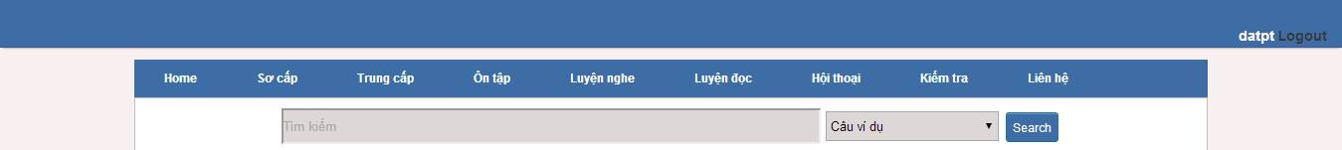

Figure 2.2: Logout

Table 2.2: Logout’s screen description:

|  |  |  |  |  |  |  |
| --- | --- | --- | --- | --- | --- | --- |
| No | Field name | Type | Require | Mandatory | Max-Length | Description |
| 1 | Logout | Button | Click | Y |  | User click on Logout button |

|  |  |  |  |  |
| --- | --- | --- | --- | --- |
| **UC007 – Logout** | | | | |
| **Use-case No.** | <UC007> | **Use-case Version** | | <1.0> |
| **Use-case Name** | Logout | | | |
| **Author** | Tuan NN | | | |
| **Date** | 09/06/2014 | **Priority** | <High > | |
| **Actor:**  Member, Admin  **Summary:**  When Member, Admin want to logout their account  **Triggers**  Click on logout button  **Preconditions:**   * Website is available * Member, Admin must be login   **Post Conditions:**  Redirect user to previous page.  **Main Success Scenario:**   |  |  |  | | --- | --- | --- | | **Step** | **User** | **System** | | 1 | Click on logout button | Redirect to homepage | | | | | |

##### UC008: <Account management Module>: Register account

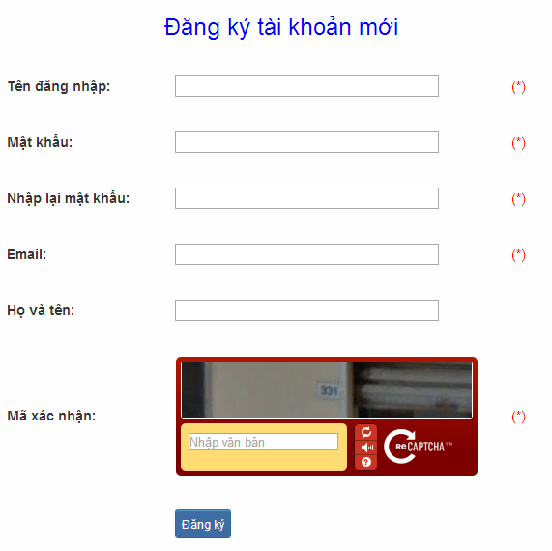

Figure 2.3: Register

Table 2.3: Register’s screen description:

|  |  |  |  |  |  |  |  |
| --- | --- | --- | --- | --- | --- | --- | --- |
| No | Field name | Field name in Vietnamese | Type | Require | Mandatory | Max-Length | Description |
| 1 | Username | Tên đăng nhập | Text | Text | Y | 32 | User input username with length less than 32 characters |
| 2 | Password | Mật khẩu | Password | Text | Y | 32 | User input their password with length less than 32 characters |
| 3 | Re-password | Nhập lại mật khẩu | Password | Text | Y | 32 | User re-input password with length less than 32 characters |
| 4 | Name | Họ và tên | Text | Text | Y | 50 | User input their name with length less than 50 characters |
| 5 | Email | Email | Text | Text | Y | 100 | User input email with length less than 32 characters |
| 6 | Capcha | Mã xác nhận | Text | Text | Y | 100 | User input the verification code |
| 7 | Register | Đăng ký | Button | Click | Y |  | User click Register button |

|  |  |  |  |  |
| --- | --- | --- | --- | --- |
| **UC008 – Register account** | | | | |
| **Use-case No.** | <UC008> | **Use-case Version** | | <1.0> |
| **Use-case Name** | Register | | | |
| **Author** | Tuan NN | | | |
| **Date** | 09/06/2014 | **Priority** | <High > | |
| **Actor:**  Guest  **Summary:**  Visitor can create new account to use more function as a register user  **Triggers**  Click on register link on the website  **Preconditions:**   * Website is available   **Post Conditions:**  Create account for guest  **Main Success Scenario:**   |  |  |  | | --- | --- | --- | | **Step** | **User** | **System** | | 1 | Enter website link on web browser | Display Homepage screen | | 2 | Click on register link | Display register form | | 3 | Enter necessary and mandatory information and click "Đăng kí" button. | Display message to register successfully and redirect to homepage |     **Alternative Scenario:**   |  |  |  | | --- | --- | --- | | **At Step** | **User** | **System** | | 3 | Enter necessary and mandatory information and click another link | Switch to selected page |   **Exceptions:**   |  |  |  | | --- | --- | --- | | **At Step** | **User** | **System** | | 3 | Missing “Tên đăng nhập” field and click “Đăng kí” button | Display error message beside “Tên đăng nhập” field. | | 3 | Enter incorrect information or missing “Mật khẩu” field and click “Đăng kí” button | Display error message beside “Mật khẩu” field. | | 3 | Missing “Họ và tên” field and click “Đăng kí” button | Display error message beside “Họ và tên” field. | | 3 | Missing “Email” field and click “Đăng kí” button | Display error message eside “Email” field. | | 3 | Enter incorrect information or missing “Mã xác nhận” field and click “Đăng kí” button | Display error message beside “Mã xác nhận” field. | | | | | |

##### UC009: <Account management Module>: Edit profile

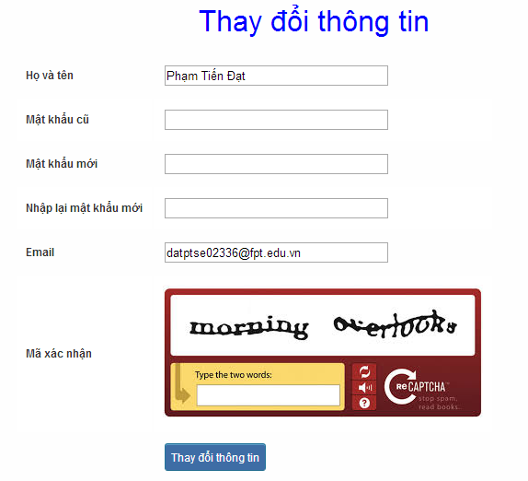

Figure 2.4: Edit profile

Table 2.4: Edit profile’s screen description:

|  |  |  |  |  |  |  |  |
| --- | --- | --- | --- | --- | --- | --- | --- |
| No | Field name | Field name in Vietnamese | Type | Require | Mandatory | Max-Length | Description |
| 1 | Name | Họ và tên | Text | Text | Y | 32 | User input their name with length less than 32 characters |
| 2 | Old-Password | Mật khẩu cũ | Password | Text | Y | 32 | User input their old password with length less than 32 characters |
| 3 | New-password | Mật khẩu mới | Password | Text | Y | 32 | User input new password with length less than 32 characters |
| 4 | Re-password | Nhập lại mật khẩu mới | Password | Text | Y | 32 | User re-input password with length less than 32 characters |
| 5 | Email | Email | Text | Text | Y | 100 | User input email to with length less than 100 characters |
| 6 | Capcha | Mã xác nhận | Text | Text | Y | 100 | User input the verification code |
| 7 | Edit | Thay đổi thông tin | Button | Click | Y |  | User click on Edit button |

|  |  |  |  |  |
| --- | --- | --- | --- | --- |
| **UC009 – Edit profile** | | | | |
| **Use-case No.** | <UC009> | **Use-case Version** | | <1.0> |
| **Use-case Name** | Edit profile | | | |
| **Author** | Tuan NN | | | |
| **Date** | 09/06/2014 | **Priority** | <High > | |
| **Actor:**  Member  **Summary:**  When member want to change their profile  **Triggers**  Login the website and click on the edit profile link  **Preconditions:**   * Website is available * Member login the website   **Post Conditions:**  Edit profile successful and redirect user to edited profile page  **Main Success Scenario:**   |  |  |  | | --- | --- | --- | | **Step** | **User** | **System** | | 1 | Enter website link on web browser | Display Homepage screen | | 2 | Enter necessary and mandatory information and click "Login” | Redirect to previous page and logged user into system. | | 3 | Click on "Trang cá nhân" link. | Display “Trang cá nhân” page | | 4 | User changes profile and click “Lưu” button | Update new profile |     **Alternative Scenario:**   |  |  |  | | --- | --- | --- | | **t Step** | **User** | **System** | | 4 | Enter necessary and mandatory information and click another link | Switch to selected page |   **Exceptions:**   |  |  |  | | --- | --- | --- | | **At Step** | **User** | **System** | | 4 | Enter new password that incorrect form or missing information and click “Lưu” button | Displa ero message | | 4 | Enter new email that incorrect form or missing information and click “Lưu” button | Display error message | | | | | |

##### UC010: <Account management Module>: Forgot password

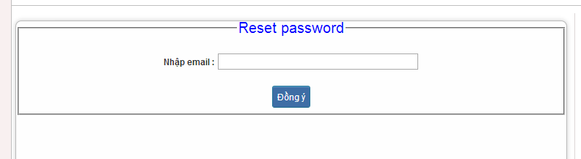

Figure 2.5: Forgot password

Table 2.5: Forgot password’s screen description:

|  |  |  |  |  |  |  |  |
| --- | --- | --- | --- | --- | --- | --- | --- |
| No | Field name | Field name in Vietnamese | Type | Require | Mandatory | Max-Length | Description |
| 1 | Email | Email | Text | Text | Y | 32 | User input email with length less than 100 characters |
| 2 | Send | Đồng ý | Button | Click | Y |  | Click to receive password |

|  |  |  |  |  |
| --- | --- | --- | --- | --- |
| **UC010 – Forgot password** | | | | |
| **Use-case No.** | <UC010> | **Use-case Version** | | <1.0> |
| **Use-case Name** | Forgot password | | | |
| **Author** | Tuan NN | | | |
| **Date** | 09/06/2014 | **Priority** | <High > | |
| **Actor:**  Member, Admin  **Summary:**  When Member, Admin forgot their password to login the system, this function will receiving their password to email  **Triggers**  Click on forgot password link on the website  **Preconditions:**   * Website is available   **Post Conditions:**  Receiving their password to their email  **Main Success Scenario:**   |  |  |  | | --- | --- | --- | | **Step** | **User** | **System** | | 1 | Enter website link on web browser | Display Homepage screen | | 2 | Click on “Quên mật khẩu link. | Display “Quên mật khẩu” page | | 3 | Enter necessary and mandatory information in the “Quên mật khẩu” form and click "Gửi yêu cầu" button. | System will send the password into your emi. |     **Alternative Scenario:**   |  |  |  | | --- | --- | --- | | **At Step** | **User** | **Syste** | | 3 | Enter necessary and mandatory information and click another link | Switch to selected page |   **Exceptions:**   |  |  |  | | --- | --- | --- | | **At Step** | **User** | **System** | | 3 | Enter email incorrect with email that use to register account | Display error message and request to re-enter email | | | | | |

### Contact admin Module

#### Use case diagram

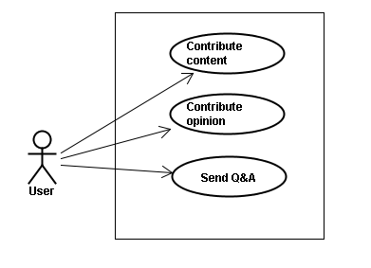

#### Use Case Specification

##### UC011 <Contact admin Module>: Contribute content

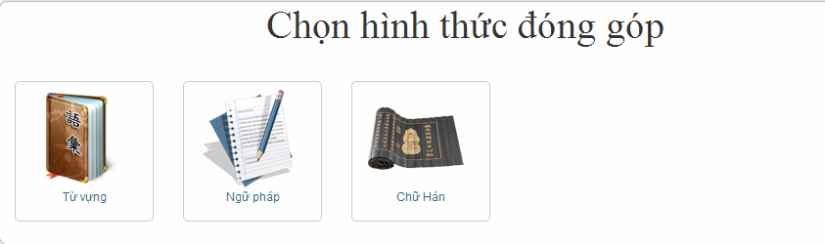

Figure 3.1: Contribute content

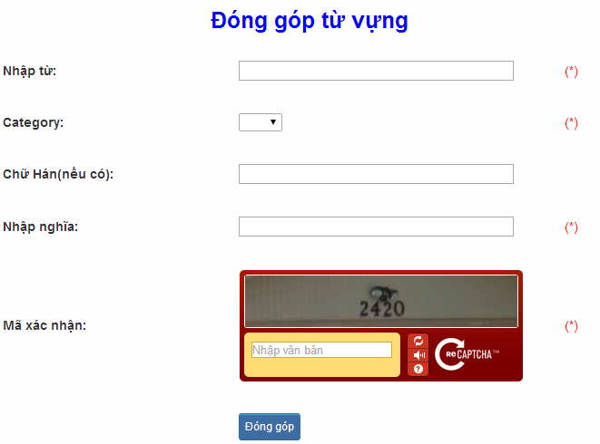

Figure 3.1.1: Contribute vocabulary

Table 3.1: Contribute vocabulary’s screen description:

|  |  |  |  |  |  |  |  |  |  |  |  |  |
| --- | --- | --- | --- | --- | --- | --- | --- | --- | --- | --- | --- | --- |
| No | | Field name | Field name in Vietnamese | | Type | Require | Mandatory | | Max-Length | | Description | |
| 1 | | Vocabulary | Từ | | Text | Text | Y | | 200 | | User input vocabulary with length less than 200 characters | |
| 2 | | Category | Loại từ | | Drop-down list | Click | Y | |  | | User choose type of category | |
| 3 | | Kanji | Chữ Hán | | Text | Text | Y | | 10 | | User input kanji of vocabulary (if exist) with length less than 10 characters | |
| 4 | | Mean | Nhập nghĩa | | Text | Text | Y | | 500 | | User input mean of vocabulary with length less than 500 characters | |
| 5 | | Capcha | Mã xác nhận | | Text | Text | Y | |  | | User input the verification code | |
| 6 | | Contribute | Đóng góp | | Button | Click | Y | |  | | User click on contribute button | |
| **UC011 – Contribute content** | | | | | | | | | | | | |
| **Use-case No.** | | | <UC011> | | | | **Use-case Version** | | | | <1.0> | |
| **Use-case Name** | | | Contribute content | | | | | | | | | |
| **Author** | | | Tuan NN | | | | | | | | | |
| **Date** | | | 09/06/2014 | | | | **Priority** | | <High > | | | |
| **Actor:**  Member  **Summary:**  When Member want to contribute content for website  **Triggers**  User enter website link and click on “Liên hệ” link on the website  **Preconditions:**   * Website is available * User must be login to the website   **Post Conditions:**  Receive opinions and redirect user to contact page  **Main Success Scenario:**   |  |  |  | | --- | --- | --- | | **Step** | **User** | **System** | | 1 | Enter website link on web browser | Display Homepage screen | | 2 | Enter necessary and mandatory information and click "Login” | Redirect to previous page and logged user into system. | | 3 | Click on “Liên hệ”->”Đóng góp database” section | Display “Đóng góp database” page | | 4 | Enter information that member want to contribute for the website then click “Đóng góp” | System will receive contributions |     **Alternative Scenario:**   |  |  |  | | --- | --- | --- | | **At Step** | **User** | **ystem** | | 4 | Enter necessary and mandatory information and click another link | Switch to selected page |   **Exceptions:**   |  |  |  | | --- | --- | --- | | **At Step** | **User** | **System** | | 4 | Missing “Nhập từ” field and click “Đóng góp” button | Display error message beside “Nhập từ” field. | | 4 | Missing “Loại từ” field and click “Đóng góp” button | Display error message beside “Loại từ” field. | | 4 | Missing “Nhập nghĩa” field and click “Đóng góp” button | Display error message beside “Nhập nghĩa” field. | | 4 | Enter incorrect information or missing “Mã xác nhận” field and click “Đóng góp” button | Display error message beside “Mã xác nhận” field. | | | | | | | | | | | | | |

##### UC012 <Contact admin Module>: Contribute opinion

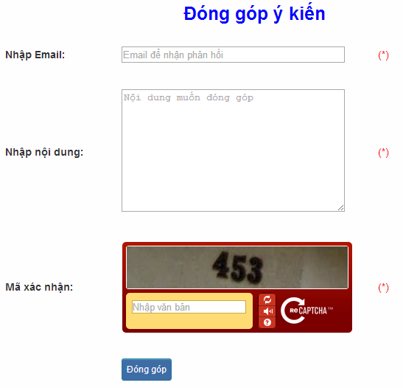

Figure 3.2: Contribute opinion

Table 3.2 : Contribute opinion’s screen description:

|  |  |  |  |  |  |  |  |
| --- | --- | --- | --- | --- | --- | --- | --- |
| No | Field name | Field name in Vietnamese | Type | Require | Mandatory | Max-Length | Description |
| 1 | Email | Email | Text | Text | Y | 100 | User input email with length less than100 characters |
| 2 | Content | Nhập nội dung | Text | Text | Y | 1000 | User input content with length less than1000 characters |
| 3 | Capcha | Mã xác nhận | Text | Text | Y |  | User input the verification code |
| 4 | Contribute | Đóng góp | Button | Click | Y |  | User click on contribute button |

|  |  |  |  |  |
| --- | --- | --- | --- | --- |
| **UC012 – Contribute opinion** | | | | |
| **Use-case No.** | <UC012> | **Use-case Version** | | <1.0> |
| **Use-case Name** | Contribute opinion | | | |
| **Author** | Tuan NN | | | |
| **Date** | 09/06/2014 | **Priority** | <High > | |
| **Actor:**  Member  **Summary:**  When Member want to contribute opinion for website  **Triggers**  User enter website link and click on “Liên hệ” link on the website  **Preconditions:**   * Website is available * User must be login to the website   **Post Conditions:**  Receive opinions and redirect user to contact page  **Main Success Scenario:**   |  |  |  | | --- | --- | --- | | **Step** | **Use** | **System** | | 1 | Enter website link on webbrowser | Display Homepage screen | | 2 | Enter necessary and mandatory information and click "Login” | Redirect to previous page and logged user into system. | | 3 | Click on “Liên hệ”->”Đóng góp ý kiến” section | Display “Đóng góp ý kiến” page | | 4 | Enter information that member want to contribute for the website then click “Đóng góp” | System will receive contributions |   **Alternative Scenario:**   |  |  |  | | --- | --- | --- | | **At Step** | **User** | **System** | | 4 | Enter necessary and mandatory information and click another link | Switch to selected page |   **Exceptions:**   |  |  |  | | --- | --- | --- | | **At Step** | **User** | **System** | | 4 | Missing “Nhập email” field and click “Đóng góp” button | Display error message beside “Nhập email” field. | | 4 | Missing “Nhập nội dung:” field and click “Đóng góp” button | Display error message beside “Nhập nội dung:” field. | | 4 | Enter incorrect information or missing “Mã xác nhận” field and click “Đóng góp” button | Display error message beside “Mã xác nhận” field. | | | | | |

##### UC013 <Contact admin Module>: Send Q&A

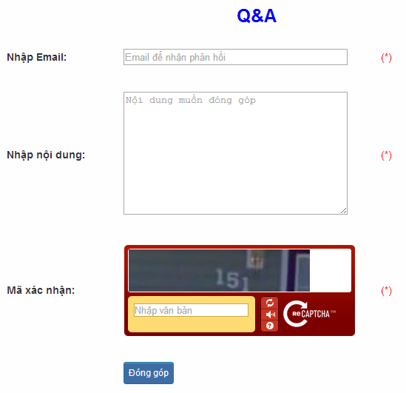

Figure 3.3: Send Q&A

Table 3.3: Send Q&A’s screen description:

|  |  |  |  |  |  |  |  |
| --- | --- | --- | --- | --- | --- | --- | --- |
| No | Field name | Field name in Vietnamese | Type | Require | Mandatory | Max-Length | Description |
| 1 | QA | Q&A | Text | Text | Y | 1000 | User input Q&A with length less than 1000 characters |
| 2 | Email | Email | Text | Text | Y | 100 | User input email with length less than 100 characters |
| 3 | Capcha | Mã xác nhận | Text | Text | Y |  | User input the verification code |
| 4 | Contribute | Đóng góp | Button | Click | Y |  | User click on contribute button |

|  |  |  |  |  |
| --- | --- | --- | --- | --- |
| **UC013 – Send Q&A** | | | | |
| **Use-case No.** | <UC013> | **Use-case Version** | | <1.0> |
| **Use-case Name** | Send Q&A | | | |
| **Author** | Tuan NN | | | |
| **Date** | 09/06/2014 | **Priority** | <High > | |
| **Actor:**  Member  **Summary:**  When Member have the question, they can create Q&A  **Triggers**  Click on “Liên hệ” link on the website  **Preconditions:**   * Website is available * User must be login to the website   **Post Conditions:**  Add new Q&A into the website  **Main Success Scenario:**   |  |  |  | | --- | --- | --- | | **Step** | **User** | **System** | | 1 | Enter website link on web browser | Display Homepage screen | | 2 | Enter necessary and mandatory information and click "Login” | Redirect to previous page and logged user into system. | | 3 | Click on “Q&A” section | Display “Q&A” page | | 4 | Enter necessary and mandatory information in the “Q&A” form and click "Gửi" button. | Display this Q&A in the “Q&A”section. |     **Alternative Scenario:**   |  |  |  | | --- | --- | --- | | **At Step** | **User** | **System** | | 4 | Enter necessary and mandatory information and click another link | Switch to selected page |   **Exceptions:**   |  |  |  | | --- | --- | --- | | **At Step** | **User** | **System** | | 4 | Missing “Nhập email” field and click “Đóng góp” button | Display error message beside “Nhập email” field. | | 4 | Missing “Q&A” field and click “Đóng góp” button | Display error message beside “Q&A” field. | | 4 | Enter incorrect information or missing “Mã xác nhận” field and click “Đóng góp” button | Display error message beside “Mã xác nhận” field. | | | | | |

### Practice management Module

#### Use case diagram

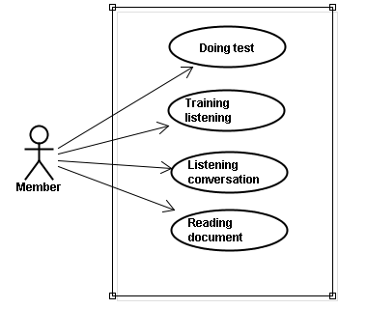

#### Use case specification

##### UC014 <Practice management Module>: Doing test

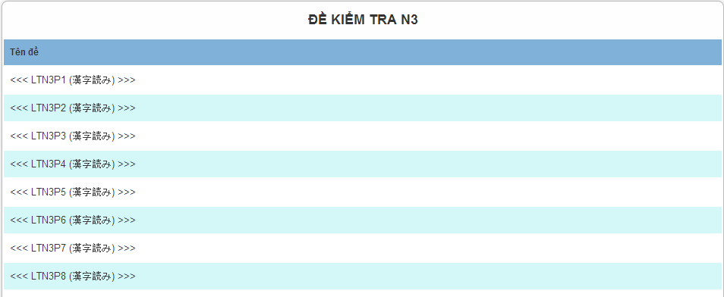

Figure 4.1: Doing test

Screen description: This is doing test screen ( N3 test screen). At here, user can doing test in the website, they click on one of test link

|  |  |  |  |  |
| --- | --- | --- | --- | --- |
| **UC014 – Doing test** | | | | |
| **Use-case No.** | <UC014> | **Use-case Version** | | <1.0> |
| **Use-case Name** | Doing test | | | |
| **Author** | Tuan NN | | | |
| **Date** | 09/06/2014 | **Priority** | <High > | |
| **Actor:**  Member  **Summary:**  This function will help users do the online quiz and check the answers, grading and evaluation capabilities  **Triggers**  User going to website, login and then click on “Kiểm tra” link on the website  **Preconditions:**   * Website is available * User must be login to the website   **Post Conditions:**  Doing test in the website  **Main Success Scenario:**   |  |  |  | | --- | --- | --- | | **Step** | **User** | **System** | | 1 | Enter website link on web browser | Display Homepage screen | | 2 | Enter necessary and mandatory information and click "Login” | Redirect to previous page and logged user into system. | | 3 | Click on “Kiểm tra” section | Display “Kiểm tra” page | | 4 | Choose one of items that you want to doing test | Display that item’s page | | 5 | Doing test | Check the answer, grading after finish |     **Alternative Scenario:**   |  |  |  | | --- | --- | --- | | **At Step** | **User** | **System** | | 5 | While doing test, click another link | Switch to selected page | | | | | |

##### UC015 <Practice management Module>: Trainng listening

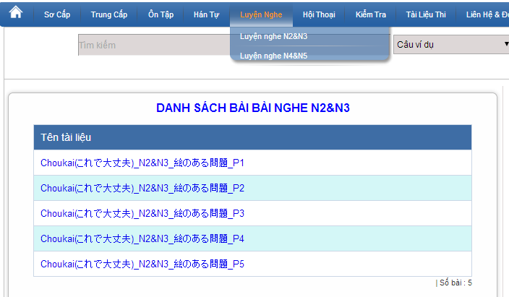

Figure 4.2: Training listening

Screen description:

|  |  |  |  |  |  |  |
| --- | --- | --- | --- | --- | --- | --- |
| No | Field name | Type | Require | Mandatory | Max-Length | Description |
| 1 | Choukai_P1 | Hyperlink | Click | N |  | Display information of listening |
| 2 | Choukai_P2 | Hyperlink | Click | N |  | Display information of listening |
| 3 | Choukai_P3 | Hyperlink | Click | N |  | Display information of listening |
| 4 | Choukai_P4 | Hyperlink | Click | N |  | Display information of listening |
| 5 | Choukai_P5 | Hyperlink | Click | N |  | Display information of listening |

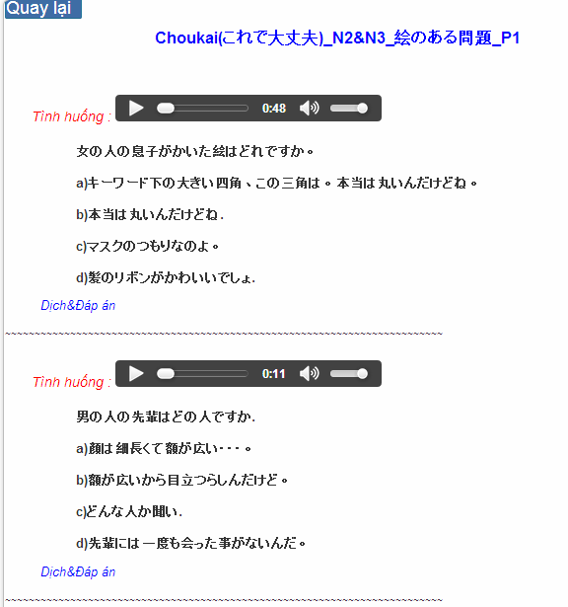

Figure 4.2.1: Training listening content

Table 4.2.1 : Training listening content’s screen description:

|  |  |  |  |  |  |  |
| --- | --- | --- | --- | --- | --- | --- |
| No | Field name | Field name in Vietnamese | Type | Require | Mandatory | Description |
| 1 | Audio | Audio | Audio | Click | Y | User click play button |
| 2 | Translation and Answer | Dịch và đáp án | Link | Click | Y | User click to display translation and answer |

|  |  |  |  |  |
| --- | --- | --- | --- | --- |
| **UC015 – Training listening** | | | | |
| **Use-case No.** | <UC015> | **Use-case Version** | | <1.0> |
| **Use-case Name** | Training listening | | | |
| **Author** | Tuan NN | | | |
| **Date** | 09/06/2014 | **Priority** | <High > | |
| **Actor:**  Guest, Member  **Summary:**  This function provide users some the listening of level N2, N3, N4 to help users training listening skill  **Triggers**  User going to website and click on “Luyện nghe” link on the website  **Preconditions:**   * Website is available   **Post Conditions:**  Training listening in the website  **Main Success Scenario:**   |  |  |  | | --- | --- | --- | | **Step** | **User** | **System** | | 1 | Enter website link on web browser | Display Homepage screen | | 2 | Click on “Luyện nghe” section | Display “Luyện nghe” page |     **Alternative Scenario:**   |  |  |  | | --- | --- | --- | | **At Stp** | **User** | **System** | | 4 | While listening, click another link | Switch to selected page | | | | | |

##### UC016 <Practice management Module>: Listening conversation

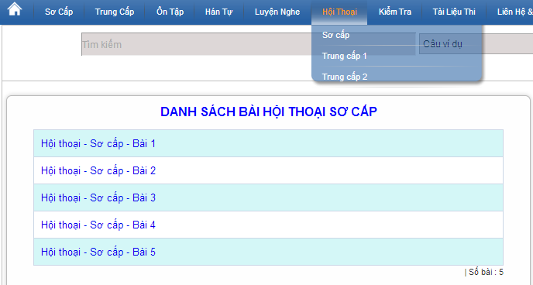

Figure 4.3: Listening conversation

Screen description:

|  |  |  |  |  |  |
| --- | --- | --- | --- | --- | --- |
| No | Field name | Type | Require | Mandatory | Description |
| 1 | SC_P1 | Hyperlink | Click | N | Display information of conversation |
| 2 | SC_P2 | Hyperlink | Click | N | Display information of conversation |
| 3 | SC_P3 | Hyperlink | Click | N | Display information of conversation |
| 4 | SC_P4 | Hyperlink | Click | N | Display information of conversation |
| 5 | SC_P5 | Hyperlink | Click | N | Display information of conversation |

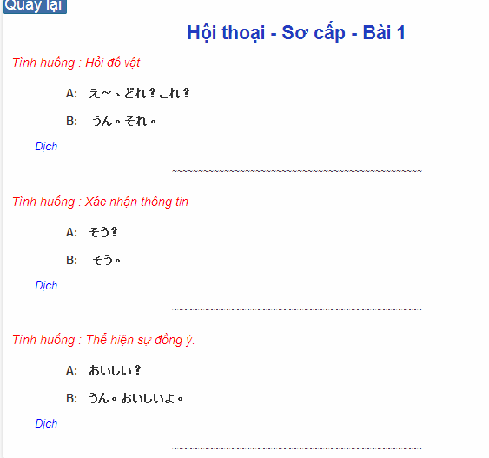

Figure 4.3.1: Conversation content

Table 4.2.1 : Training listening content’s screen description:

|  |  |  |  |  |  |  |
| --- | --- | --- | --- | --- | --- | --- |
| No | Field name | Field name in Vietnamese | Type | Require | Mandatory | Description |
| 1 | Translation | Dịch | Link | Click | Y | User click to display translation |

|  |  |  |  |  |
| --- | --- | --- | --- | --- |
| **UC016 – Listening conversation** | | | | |
| **Use-case No.** | <UC016> | **Use-case Version** | | <1.0> |
| **Use-case Name** | Listening conversation | | | |
| **Author** | Tuan NN | | | |
| **Date** | 09/06/2014 | **Priority** | <High > | |
| **Actor:**  Guest, Member  **Summary:**  This function provide users some the conversation in everyday life and common situations (eg: restaurants, shopping, in hospital ..)  **Triggers**  Click on “Hội thoại” link on the website  **Preconditions:**   * Website is available   **Post Conditions:**  Listening conversation in the website  **Main Success Scenario:**   |  |  |  | | --- | --- | --- | | **Step** | **User** | **System** | | 1 | Enter websie link n web browser | Display Homepage screen | | 2 | Click on “Hội thoại” section | Display “Hội thoại” page |     **Alternative Scenario:**   |  |  |  | | --- | --- | --- | | **At Step** | **User** | **System** | | 4 | While listening, click another link | Switch to selected page | | | | | |

##### UC017 < Practice management Module>: Reading document

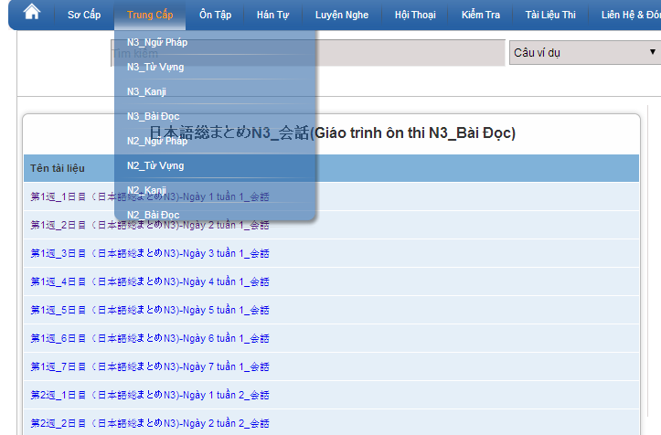

Figure 4.4: Reading document

Screen description: This is reading screen. At here, user can read document in the website, there are some lesson to reading in the reading document.

|  |  |  |  |  |
| --- | --- | --- | --- | --- |
| **UC017 – Reading document** | | | | |
| **Use-case No.** | <UC017> | **Use-case Version** | | <1.0> |
| **Use-case Name** | Reading document | | | |
| **Author** | Tuan NN | | | |
| **Date** | 09/06/2014 | **Priority** | <High > | |
| **Actor:**  Guest, Member  **Summary:**  This function provide users some document : elementary, intermediate and review.  **Triggers**  Click on “N3/N2 Bài đọc” link on the website  **Preconditions:**   * Website is available   **Post Conditions:**  Reading document in the website  **Main Success Scenario:**   |  |  |  | | --- | --- | --- | | **Step** | **User** | **System** | | 1 | Enter website link on web browser | Display Homepage screen | | 2 | Click on “Bài đọc” section | Display “Bài đọc” page |     **Alternative Scenario:**   |  |  |  | | --- | --- | --- | | **At Step** | **User** | **System** | | 4 | While reading, click another link | Switch to selected page | | | | | |

### Admin’s account management

#### Use case diagram

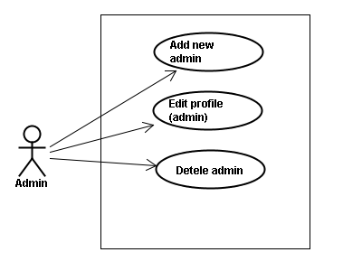

#### Use case specifications

##### UC018 <Admin’s account management>: Add new admin

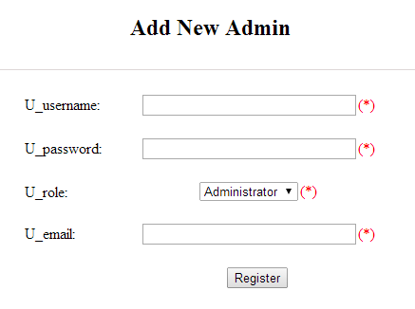

Figure 5.1: Add new admin

Table 5.1: Add new admin’s screen description:

|  |  |  |  |  |  |  |
| --- | --- | --- | --- | --- | --- | --- |
| No | Field name | Type | Require | Mandatory | Max-Length | Description |
| 1 | Username | Text | Text | Y | 32 | Admin input username of admin’s account with length less than 32 characters |
| 2 | Password | Text | Text | Y | 100 | Admin input password of admin’s account with length less than 32 characters |
| 3 | Roll | Drop-down list | Choose | Y |  | Admin choose the roll of account |
| 4 | Email | Text | Text | Y | 100 | Admin input email of admin’s account with length less than 100 characters |
| 5 | Add | Button | Click | Y |  | Admin add new admin |

|  |  |  |  |  |
| --- | --- | --- | --- | --- |
| **UC018 – Add new admin** | | | | |
| **Use-case No.** | <UC018> | **Use-case Version** | | <1.0> |
| **Use-case Name** | Add new admin | | | |
| **Author** | Tuan NN | | | |
| **Date** | 09/06/2014 | **Priority** | <High > | |
| **Actor:**  Admin  **Summary:**  Administrator can add new admin  **Triggers**  Admin login the website and click on add new admin link on the website  **Preconditions:**   * Website is available * Admin login to the website   **Post Conditions:**  New admin be added successfully  **Main Success Scenario:**   |  |  |  | | --- | --- | --- | | **Step** | **User** | **System** | | 1 | Enter website link on web browser | Display Homepage screen | | 2 | Enter necessary and mandatory information and click "Login” | Redirect to previous page and logged admin into system. | | 3 | Click on add new admin section | Display add new admin page | | 4 | Enter account that you want to add | Add new admin and display message to add new successfully |     **Alternative Scenario:**   |  |  |  | | --- | --- | --- | | **At Step** | **User** | **System** | | 4 | Input data in account area then click on another link | Switch to selected page |   **Exceptions:**   |  |  |  | | --- | --- | --- | | **At Step** | **User** | **System** | | 4 | Fill incorrect account name | Return Error message | | | | | |

##### UC019 <Admin’s account management>: Edit profile (admin)

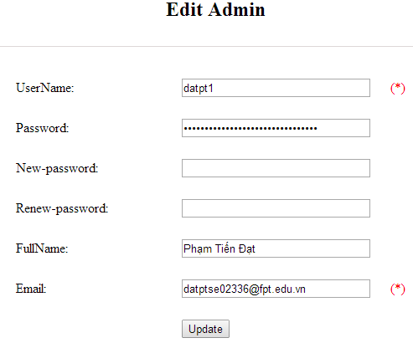

Figure 5.2: Edit profile admin

Table 5.2: Edit profile admin’s screen description:

|  |  |  |  |  |  |  |
| --- | --- | --- | --- | --- | --- | --- |
| No | Field name | Type | Require | Mandatory | Max-Length | Description |
| 1 | Username | Text | Text | N |  | Username of admin’s account |
| 2 | Old-password | Text | Text | Y | 32 | Admin input old password with length less than 32 characters |
| 3 | New-password | Text | Text | Y | 32 | Admin input new password with length less than 32 characters |
| 4 | Renew-password | Text | Text | Y | 32 | Admin re-input new password with length less than 32 characters |
| 5 | Fullname | Text | Text | Y | 100 | Admin input full name with length less than 100 characters |
| 6 | Email | Text | Text | Y | 100 | Admin input email with length less than 100 characters |
| 7 | Update | Button | Click | Y |  | User click to edit vocabulary |

|  |  |  |  |  |
| --- | --- | --- | --- | --- |
| **UC019 – Edit profile(admin)** | | | | |
| **Use-case No.** | <UC019> | **Use-case Version** | | <1.0> |
| **Use-case Name** | Edit profile admin | | | |
| **Author** | Tuan NN | | | |
| **Date** | 09/06/2014 | **Priority** | <High > | |
| **Actor:**  Administrator  **Summary:**  Administrator want to change their profile  **Triggers**  Administrator login the website and click on the edit profile link  **Preconditions:**   * Website is available * Administrator login the website   **Post Conditions:**  Edit admin profile and redirect to edited profile page  **Main Success Scenario:**   |  |  |  | | --- | --- | --- | | **Step** | **User** | **System** | | 1 | Enter website link on web browser | Display Homepage screen | | 2 | Enter necessary and mandatory information and click "Login” | Redirect to previous page and logged admin into system. | | 3 | Click on "Trang cá nhân" link. | Display “Trang cá nhân” page | | 4 | Admin changes profile and click “Lưu” button | Update new profile |   **Alternative Scenario:**   |  |  |  | | --- | --- | --- | | **At Step** | **User** | **System** | | 4 | Enter necessary and mandatory information and click another link | Switch to selected page |   **Exceptions:**   |  |  |  | | --- | --- | --- | | **At Step** | **User** | **System** | | 4 | Enter new password that incorrect form or missing information and click “Lưu” button | Display error message | | 4 | Enter new email that incorrect form or missing information and click “Lưu” button | Display error message | | | | | |

##### UC020 <Admin’s account management>: Delete admin

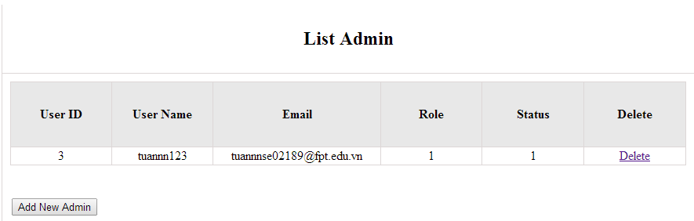

Figure 5.3: Delete admin

|  |  |  |  |  |
| --- | --- | --- | --- | --- |
| **UC020 – Delete admin** | | | | |
| **Use-case No.** | <UC020> | **Use-case Version** | | <1.0> |
| **Use-case Name** | Delete admin | | | |
| **Author** | Tuan NN | | | |
| **Date** | 09/06/2014 | **Priority** | <High > | |
| **Actor:**  Administrator  **Summary:**  Administrators can remove administrator rights of other admin  **Triggers**  Login the website and click on the delete admin link  **Preconditions:**   * Website is available * Admin login the website   **Post Conditions:**  Admin will be remove administrator rights  **Main Success Scenario:**   |  |  |  | | --- | --- | --- | | **Step** | **User** | **System** | | 1 | Enter website link on web browser | Display Homepage screen | | 2 | Enter necessary and mandatory information and click "Login” | Redirect to previous page and logged admin into system. | | 3 | Click on delete admin link. | Display delete admin page | | 4 | Enter the account that you want to remove administrator rights | Remove administrator rights of account and display message to remove successfully |     **Alternative Scenario:**   |  |  |  | | --- | --- | --- | | **At Step** | **User** | **System** | | 4 | Input data in account area then click on another link | Switch to selected page |   **Exceptions:**   |  |  |  | | --- | --- | --- | | **At Step** | **User** | **System** | | 4 | Fill incorrect account name | Return Error message | | | | | |

### Management Member’s account

#### Use case diagram

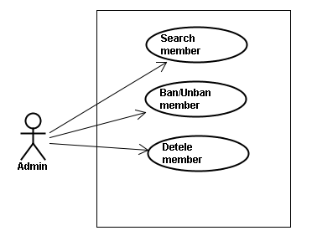

#### Screen description

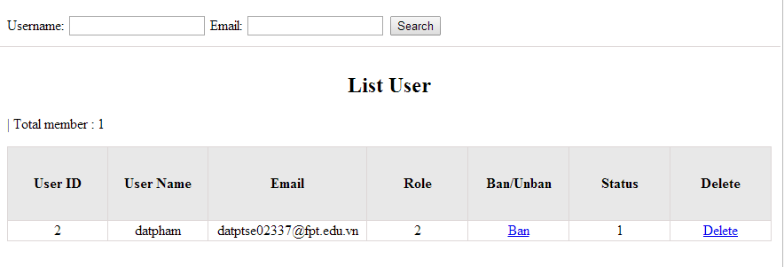

Figure 6: Management Member

Table 6: Management member’s screen description:

|  |  |  |  |  |  |  |
| --- | --- | --- | --- | --- | --- | --- |
| No | Field name | Type | Require | Mandatory | Max-Length | Description |
| 1 | Username | Text | Text | Y | 32 | Admin input username to search member by username |
| 2 | Email | Text | Text | Y | 100 | Admin input email to search member by email |
| 3 | Ban/Unban | Button | Click | N |  | Admin click ban/unban member |
| 4 | Delete | Button | Click | N |  | Admin click delete member |

#### Use case specifications

##### UC021 <Management Member’s account>: Search member

Search member screen:

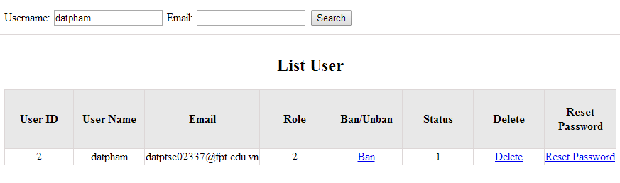

|  |  |  |  |  |
| --- | --- | --- | --- | --- |
| **UC021 – Search member** | | | | |
| **Use-case No.** | <UC021> | **Use-case Version** | | <1.0> |
| **Use-case Name** | Search member | | | |
| **Author** | Tuan NN | | | |
| **Date** | 09/06/2014 | **Priority** | <High > | |
| **Actor:**  Admin  **Summary:**  When admin want to search by member’s account in database successfully if it is existed  **Triggers**  Admin login the website and click on search member , input member’s account in the right text box then click “Search” button  **Preconditions:**   * Website is available * Admin must be login * Input data must be correctly   **Post Conditions:**  Display detail information of member  **Main Success Scenario:**   |  |  |  | | --- | --- | --- | | **Step** | **User** | **System** | | 1 | Enter website link on web browser | Display Homepage screen | | 2 | Enter necessary and mandatory information and click "Login” | Redirect to previous page and logged admin into system. | | 3 | Click on "Search member" button and input member’s account or email | Display “member information” screen that contains the information :   * User ID * User Name * Email * Phone number * Role * Ban/Unban * Status * Delete |     **Alternative Scenario:**   |  |  |  | | --- | --- | --- | | **At Step** | **User** | **System** | | 3 | Fill information of the member that they want to find into these fields then click on another link | Switch to selected page |   **Exceptions:**   |  |  |  | | --- | --- | --- | | **At Step** | **User** | **System** | | 3 | Fill information of the member that they want to find (that do not exist in database) into these fields then click “Search” button | Return Error message to inform that member cannot be found | | | | | |

##### UC022 <Management Member’s account>: Ban/Unban member

|  |  |  |  |  |
| --- | --- | --- | --- | --- |
| **UC022 – Search member** | | | | |
| **Use-case No.** | <UC022> | **Use-case Version** | | <1.0> |
| **Use-case Name** | Ban/Unban member | | | |
| **Author** | Tuan NN | | | |
| **Date** | 09/06/2014 | **Priority** | <High > | |
| **Actor:**  Admin  **Summary:**  When admin can ban user who violated rule of website and unban member  **Triggers**  Admin login the website and click on member’s account and then click “Ban/Unban” button  **Preconditions:**   * Website is available * Admin must be login * Input data must be correctly   **Post Conditions:**  Member’s account will be ban/unban by administrator  **Main Success Scenario:**   |  |  |  | | --- | --- | --- | | **Step** | **User** | **System** | | 1 | Enter website link on web browser | Display Homepage screen | | 2 | Enter necessary and mandatory information and click "Login” | Redirect to previous page and logged admin into system. | | 3 | Click on "Search member" button and input member’s account or email | Display “member information” screen that contains the information | | 4 | Click “Ban/Unban” link | Ban/Unban member |   **Alternative Scenario:**   |  |  |  | | --- | --- | --- | | **At Step** | **User** | **System** | | 3 | Fill information of the member that they want to find into these fields then click on another link | Switch to selected page |   **Exceptions:**   |  |  |  | | --- | --- | --- | | **At Step** | **User** | **System** | | 3 | Fill information of the member that they want to find (that do not exist in database) into these fields then click “Search” button | Return Error message to inform that member cannot be found | | | | | |

##### UC023 <Management Member’s account>: Delete member

|  |  |  |  |  |
| --- | --- | --- | --- | --- |
| **UC023 – Delete member** | | | | |
| **Use-case No.** | <UC023> | **Use-case Version** | | <1.0> |
| **Use-case Name** | Delete member | | | |
| **Author** | Tuan NN | | | |
| **Date** | 09/06/2014 | **Priority** | <High > | |
| **Actor:**  Admin  **Summary:**  Administrators can delete member who violated rule of website  **Triggers**  Admin login the website and click on the delete member link  **Preconditions:**   * Website is available * Admin must be login * Input data must be correctly   **Post Conditions:**  Member’s account will be removed from system  **Main Success Scenario:**   |  |  |  | | --- | --- | --- | | **Step** | **User** | **System** | | 1 | Enter website link on web browser | Display Homepage screen | | 2 | Enter necessary and mandatory information and click "Login” | Redirect to previous page and logged admin into system. | | 3 | Click on "Search member" button and input member’s account or email | Display information of member | | 4 | Click on delete link corresponding with member want to delete | Remove member from list |     **Alternative Scenario:**   |  |  |  | | --- | --- | --- | | **At Step** | **User** | **System** | | 3 | Fill information of the member that they want to find into these fields then click on another link | Switch to selected page |   **Exceptions:**   |  |  |  | | --- | --- | --- | | **At Step** | **User** | **System** | | 3 | Fill information of the member that they want to find (that do not exist in database) into these fields then click “Search” button | Return Error message to inform that member cannot be found | | | | | |

### Vocabulary Management

#### Use case diagram

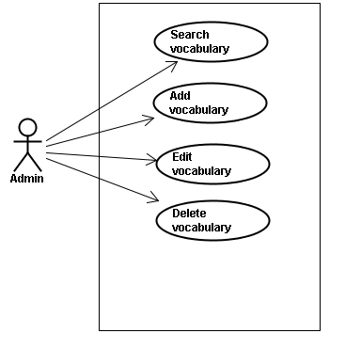

#### Screen description

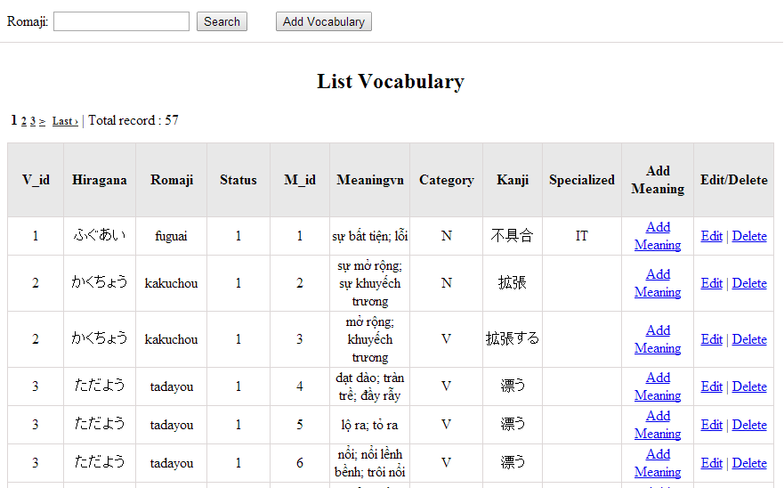

Figure 7: Vocabulary management

Table 7.1: Vocabulary management’s screen description:

|  |  |  |  |  |  |  |
| --- | --- | --- | --- | --- | --- | --- |
| No | Field name | Type | Require | Mandatory | Max-Length | Description |
| 1 | Romaji | Text | Text | Y | 100 | Admin input romaji with length less than 100 character |
| 2 | Addnew | Button | Click | N |  | Admin add new vocabulary into database |
| 3 | Add meaning | Button | Click | Y |  | Admin add meaning of vocabulary |
| 4 | Edit | Button | Click | N |  | Admin click edit vocabulary |
| 5 | Delete | Button | Click | N |  | Admin click delete vocabulary |

#### Use case specifications

##### UC024 <Vocabulary Management>: Search vocabulary

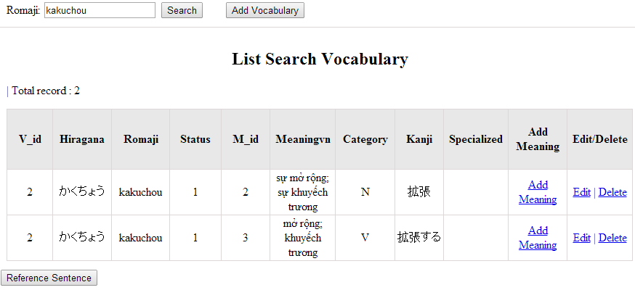

Figure 7.1: Search vocabulary

|  |  |  |  |  |
| --- | --- | --- | --- | --- |
| **UC0024 – Specification** | | | | |
| **Use-case No.** | <UC0024> | **Use-case Version** | | <1.0> |
| **Use-case Name** | Search vocabulary | | | |
| **Author** | TuanNN | | | |
| **Date** | 09/06/2014 | **Priority** | <High > | |
| **Actor:**  Admin  **Summary:**  When Administrator want to search a vocabulary on database  **Goal:**  Administrator can search vocabulary in database successfully if it is existed  **Triggers**  Admin login the website and click on “Vocabulary management” tab, input vocabulary in the right text box then click “Search” button  **Preconditions:**   * Website is available * Admin must be login * Input data must be correctly   **Post Conditions:**  Display detail information of vocabulary  **Main Success Scenario:**   |  |  |  | | --- | --- | --- | | **Step** | **User** | **System** | | 1 | Enter website link on web browser | Display Homepage screen | | 2 | Enter necessary and mandatory information and click "Login” | Redirect to previous page and logged admin into system. | | 4 | Click on “vocabulary management” tab | Displays criteria search screen | | 5 | Fill information of the vocabulary that they want to find into these fields then click “Search” button | Displays search result as a table with these elements:   * Vocabulary ID * V_Hiragana * V_Romaji * Meaning * Category * Kanji * Edit * Delete |     **Alternative Scenario:**   |  |  |  | | --- | --- | --- | | **At Step** | **User** | **System** | | 5 | Fill information of the vocabulary that they want to find into these fields then click on another link | Switch to selected page |   **Exceptions:**   |  |  |  | | --- | --- | --- | | **At Step** | **User** | **System** | | 5 | Fill information of the vocabulary that they want to find (that do not exited in database) into these fields then click “Search” button | Return Error message to inform that vocabulary structure cannot be found | | | | | |

##### UC025 <Vocabulary Management>: Add vocabulary

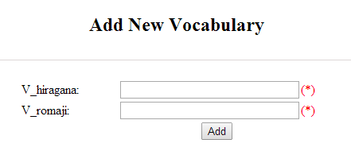

Figure 7.2: Add new vocabulary

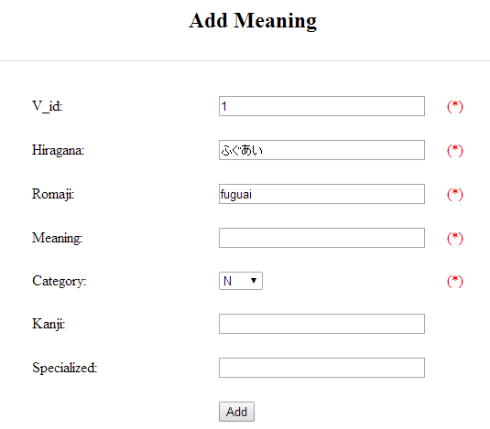

Figure 7.2.1: Add vocabulary meaning

Table 7.2: Add new vocabulary & meaning’s screen description:

|  |  |  |  |  |  |  |
| --- | --- | --- | --- | --- | --- | --- |
| No | Field name | Type | Require | Mandatory | Max-Length | Description |
| 1 | Hiragana | Text | Text | Y | 200 | Admin input vocabulary by hiragana with length less than 200 characters |
| 2 | Romaji | Text | Text | Y | 200 | Admin input vocabulary by romaji with length less than 200 characters |
| 3 | Meaning | Text | Text | Y | 500 | Admin input mean of vocabulary with length less than 500 characters |
| 4 | Category | Drop-down list | Click | Y |  | Admin choose category of vocabulary |
| 5 | Kanji | Text | Text | Y | 10 | Admin input vocabulary by kanji with length less than 10 characters |
| 6 | Specialized | Text | Text | Y | 200 | Admin input specialized of vocabulary with leng less than 200 characters |
| 7 | Add | Button | Click | Y |  | Admin add new vocabulary |

|  |  |  |  |  |
| --- | --- | --- | --- | --- |
| **UC0025 - Specification** | | | | |
| **Use-case No.** | <UC0025> | **Use-case Version** | | <1.0> |
| **Use-case Name** | Add vocabulary | | | |
| **Author** | Tuan NN | | | |
| **Date** | 09/06/2014 | **Priority** | <High > | |
| **Actor:**  Admin  **Summary:**  When Administrator want to add a vocabulary into database. They have to insert all necessary data of vocabulary into “Add new vocabulary” screen  **Goal:**  Administrator can add new vocabulary information in database successfully  **Triggers**  User must click on “Vocabulary management/ Add new” tab and input all necessary information of vocabulary into the right fields then click on “Add new” button  **Preconditions:**   * Website is available * User have logged into system as an admin. * All mandatory fields have been filled * All input data must be valid and have not existed in system   **Post Conditions:**  New vocabulary has been saved into system database successfully  **Main Success Scenario:**   |  |  |  | | --- | --- | --- | | **Step** | **User** | **System** | | 1 | Enter website link on web browser | Display Homepage screen | | 2 | Enter necessary and mandatory information and click "Login” | Redirect to previous page and logged admin into system. | | 3 | Click on “Vocabulary management/Add new” tab | Display “Add New Vocabulary” screen that contains these elements:   * V_Vocabulary * V_Romaji * V_Meaning * V_Category * V_Kanji | | 4 | Fill information into all necessary or mandatory fields and click “Add” button | The system validates the input data and then save new vocabulary data into database | | 4 | Click “Reset” | Clear all data in fields |     **Alternative Scenario:**   |  |  |  | | --- | --- | --- | | **At Step** | **User** | **System** | | 4 | Click on another link | Do not save new vocabulary data into database then redirect to selected page |   **Exceptions:**   |  |  |  | | --- | --- | --- | | **At Step** | **User** | **System** | | 4 | Do not fill full information into fields then click “Add” button | Return Error message beside empty field and ask if user want to add with empty field. | | | | | |

##### UC026 <Vocabulary Management>: Edit vocabulary

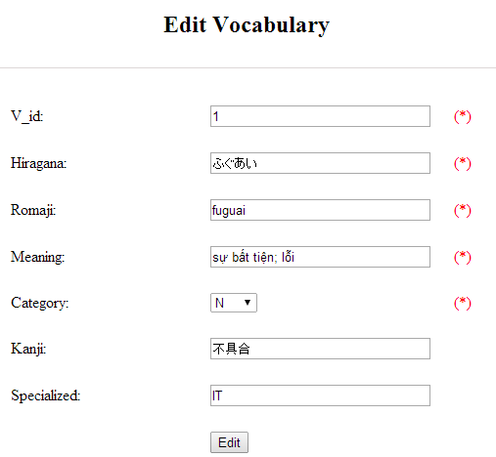

Figure 7.3: Edit vocabulary

Table 7.3: Edit vocabulary’s screen description:

|  |  |  |  |  |  |  |
| --- | --- | --- | --- | --- | --- | --- |
| No | Field name | Type | Require | Mandatory | Max-Length | Description |
| 1 | Hiragana | Text | Text | Y | 200 | Admin input vocabulary by hiragana with length less than 200 characters |
| 2 | Romaji | Text | Text | Y | 200 | Admin input vocabulary by romaji with length less than 200 characters |
| 3 | Meaning | Text | Text | Y | 500 | Admin input mean of vocabulary with length less than 500 characters |
| 4 | Category | Drop-down list | Click | Y |  | Admin choose category of vocabulary |
| 5 | Kanji | Text | Text | Y | 10 | Admin input vocabulary by kanji with length less than 10 characters |
| 6 | Specialized | Text | Text | Y | 200 | Admin input specialized of vocabulary with leng less than 200 characters |
| 7 | Edit | Button | Click | Y |  | Admin edit vocabulary |

|  |  |  |  |  |
| --- | --- | --- | --- | --- |
| **UC0026 - Specification** | | | | |
| **Use-case No.** | <UC0026> | **Use-case Version** | | <1.0> |
| **Use-case Name** | Edit vocabulary | | | |
| **Author** | TuanNN | | | |
| **Date** | 09/06/2014 | **Priority** | <High > | |
| **Actor:**  Admin  **Summary:**  When Administrator want to edit a vocabulary on database which has some new meanings or errors  **Goal:**  Administrator can edit vocabulary information in database successfully  **Triggers**  User must click on “Vocabulary management” then search for the vocabulary. User click on “Edit” link on corresponding vocabulary. They edit necessary information in the right fields then click on “Edit” button.  **Preconditions:**   * Website is available * User have logged into system as an admin. * All mandatory fields have been filled * All input data must be valid and have not existed in system   **Post Conditions:**  Changed information of vocabulary has been saved into system database successfully  **Main Success Scenario:**   |  |  |  | | --- | --- | --- | | **Step** | **User** | **System** | | 1 | Enter website link on web browser | Display Homepage screen | | 2 | Enter necessary and mandatory information and click "Login” | Redirect to previous page and logged admin into system. | | 3 | Click on “Vocabulary management ” then search for the vocabulary that they want to edit | Displays search result as a table | | 4 | Click on “Edit” link | Display “Edit Vocabulary” screen that contains the information of chosen vocabulary with these elements:   * V_Vocabulary * V_Romaji * V_Meaning * V_Category * V_Kanji | | 5 | Edit vocabulary information and click “Edit” button | The system validates the input data and then save data into database |     **Alternative Scenario:**   |  |  |  | | --- | --- | --- | | **At Step** | **User** | **System** | | 5 | Edit vocabulary information then click to another link | Do not save edited data then redirect to selected page |   **Exceptions:**   |  |  |  | | --- | --- | --- | | **At Step** | **User** | **System** | | 4 | Edit vocabulary information to be similar to another existed grammar |  | | 5 | Click “Edit” button | The system validates the input data and return Error message and do not save edited data into database |   **Reference:**  UC0024 - Search Vocabulary | | | | |

##### UC027 <Vocabulary Management>: Delete vocabulary

|  |  |  |  |  |
| --- | --- | --- | --- | --- |
| **UC0027 - Specification** | | | | |
| **Use-case No.** | <UC0027> | **Use-case Version** | | <1.0> |
| **Use-case Name** | Delete vocabulary | | | |
| **Author** | TuanNN | | | |
| **Date** | 09/06/2014 | **Priority** | <High > | |
| **Actor:**  Admin  **Summary:**  When Administrator want to delete a vocabulary on database  **Goal:**  Administrator can delete selected vocabulary in database successfully  **Triggers**  User must click on “Vocabulary management” then search for the vocabulary. User click on “Delete” link on corresponding vocabulary.  **Preconditions:**   * Website is available * User have logged into system as an admin. * All mandatory fields have been filled * All input data must be valid and have existed in system   **Post Conditions:**  Vocabulary has been deleted from system database successfully  **Main Success Scenario:**   |  |  |  | | --- | --- | --- | | **Step** | **User** | **System** | | 1 | Enter website link on web browser | Display Homepage screen | | 2 | Enter necessary and mandatory information and click "Login” | Redirect to previous page and logged admin into system. | | 3 | Click on “Vocabulary management ” then search for the vocabulary that they want to delete | Displays search result as a table | | 4 | Click on “Delete” link beside that vocabulary row | Remove that vocabulary from list |   **Exceptions:**   |  |  |  | | --- | --- | --- | | **At Step** | **User** | **System** | |  |  |  |   **Reference:**  UC0024 - Search vocabulary | | | | |
|  | | | | |

### Grammar Management

#### Use case diagram

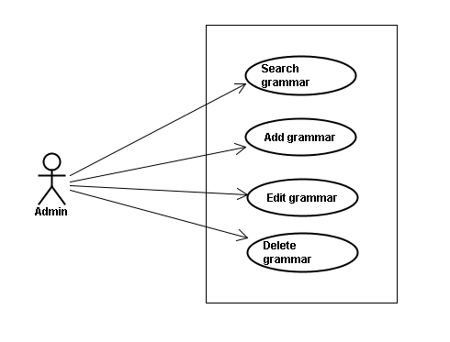

#### Screen description

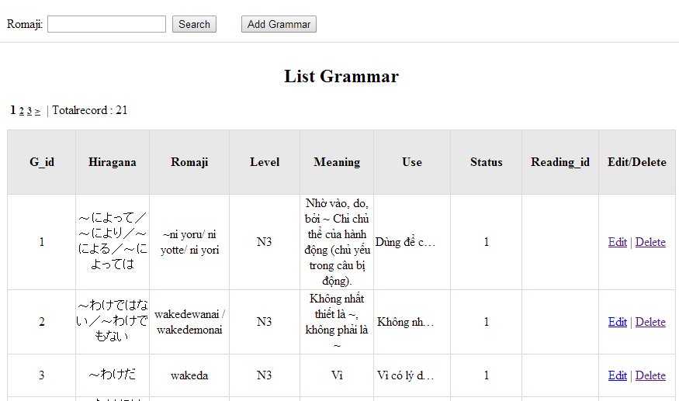

Figrure 8: Grammar management

Table 8.1: Grammar management’s screen description:

|  |  |  |  |  |  |  |
| --- | --- | --- | --- | --- | --- | --- |
| No | Field name | Type | Require | Mandatory | Max-Length | Description |
| 1 | Romaji | Text | Text | Y | 100 | Admin input romaji with length less than 100 character |
| 2 | Addnew | Button | Click | N |  | Admin add new grammar into database |
| 3 | Edit | Button | Click | N |  | Admin click edit grammar |
| 4 | Delete | Button | Click | N |  | Admin click delete grammar |

#### Use case specifications

##### UC0028: <Admin> Search grammar

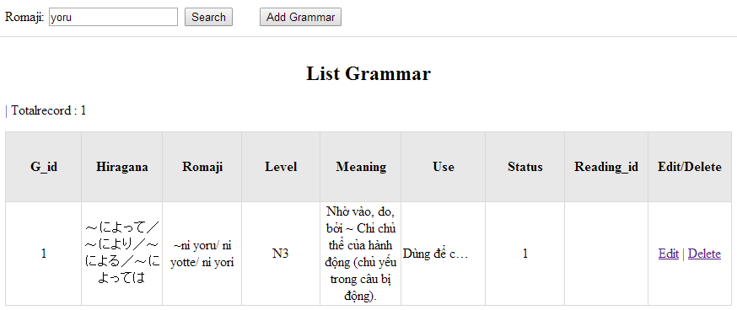

Figure 8.1: Search grammar

|  |  |  |  |  |
| --- | --- | --- | --- | --- |
| **UC0028 - Specification** | | | | |
| **Use-case No.** | <UC0028> | **Use-case Version** | | <1.0> |
| **Use-case Name** | Search grammar | | | |
| **Author** | Minh PT | | | |
| **Date** | 09/06/2014 | **Priority** | <High > | |
| **Actor:**  Admin  **Summary:**  When Administrator wants to search a grammatical structure in database, Admin can input a grammatical structure by “romaji” letter then click button “Search”. If that grammatical structure is existed, system will return meaning.  **Triggers**  Click on “Grammar management” tab, input grammatical structure in the right text box then click “Search” button  **Preconditions:**   * Website is available * User has to login as Administrator * User has to input data in search area   **Post Conditions:**  Display detail information of grammatical structure  **Main Success Scenario:**   |  |  |  | | --- | --- | --- | | **Step** | **User** | **System** | | 1 | Have logged into system as an admin |  | | 2 | Click on “Grammar management” tab | Displays criteria search screen | | 3 | Fill information of the grammatical structure that they want to find into these fields then click “Search” button | Displays search result as a table with these elements:   * Grammar ID * G_Hiragana * G_Romaji * Level * Meaning * Use * Example * Status * Edit * Delete |     **Alternative Scenario:**   |  |  |  | | --- | --- | --- | | **At Step** | **User** | **System** | | 3 | Fill information of the grammatical structure that they want to find into these fields then click on another link | Switch to selected page |   **Exceptions:**   |  |  |  | | --- | --- | --- | | **At Step** | **User** | **System** | | 3 | Fill information of the grammatical structure that they want to find (that do not exited in database) into these fields then click “Search” button | Return Error message to inform that grammatical structure cannot be found | | | | | |

##### UC0029: <Admin> Add grammar

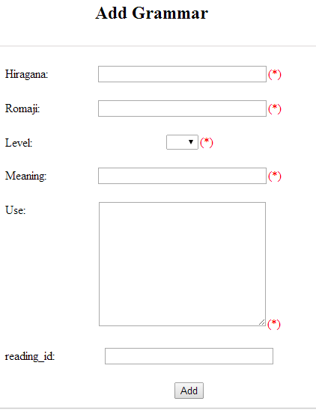

Figure 8.2: Add grammar

Table 8.2: Add grammar’s screen description:

|  |  |  |  |  |  |  |
| --- | --- | --- | --- | --- | --- | --- |
| No | Field name | Type | Require | Mandatory | Max-Length | Description |
| 1 | Hiragana | Text | Text | Y | 200 | Admin input grammar by hiragana with length less than 200 characters |
| 2 | Romaji | Text | Text | Y | 200 | Admin input grammar by romaji with length less than 200 characters |
| 3 | Meaning | Text | Text | Y | 200 | Admin input mean of grammar with length less than 200 characters |
| 4 | Use | Text | Text | Y | 1000 | Admin input use of grammar with length less than 1000 characters |
| 5 | Level | Drop-down list | Choose | Y |  | Admin choose level of grammar |
| 6 | Reading_id | Text | Text | Y | 20 | Admin input reading_id |
| 7 | Add | Button | Click | Y |  | Admin add new grammar |

|  |  |  |  |  |
| --- | --- | --- | --- | --- |
| **UC0029 - Specification** | | | | |
| **Use-case No.** | <UC0029> | **Use-case Version** | | <1.0> |
| **Use-case Name** | Add grammar | | | |
| **Author** | Minh PT | | | |
| **Date** | 09/06/2014 | **Priority** | <High > | |
| **Actor:**  Admin  **Summary:**  When Administrator wants to add a grammar into database. They have to insert all necessary data of grammar into “Add Grammar” screen then click “Add” button  **Triggers**  User must click on “Grammar management/ Add New” and input all necessary information of grammar into the right fields then click on “Add” button  **Preconditions:**   * Website is available * User has to login as Administrator * All mandatory fields have been filled * All input data must be valid and have not existed in system   **Post Conditions:**  New grammatical structure has been saved into system database successfully  **Main Success Scenario:**   |  |  |  | | --- | --- | --- | | **Step** | **User** | **System** | | 1 | Have logged into system as an admin |  | | 2 | Click on “Grammar management/Add New” | Display “Add Grammar” screen that contains these elements:   * G_hiragana * G_romaji * G_Meaning * G_Use * G_Example * G_Status | | 3 | Fill grammar information into all necessary or mandatory fields |  | | 4 | Click “Add” button | The system validates the input data and then save new grammar data into database | | 4 | Click “Reset” button | The system clear all data in text fields and text area |     **Alternative Scenario:**   |  |  |  | | --- | --- | --- | | **At Step** | **User** | **System** | | 4 | Click on another link | Do not save new grammar data into database then redirect to selected page |   **Exceptions:**   |  |  |  | | --- | --- | --- | | **At Step** | **User** | **System** | | 4 | Do not fill full information into fields then click “Add” button | Return Error message and request user input data into all fields | | | | | |

##### UC0030: <Admin> Edit grammar

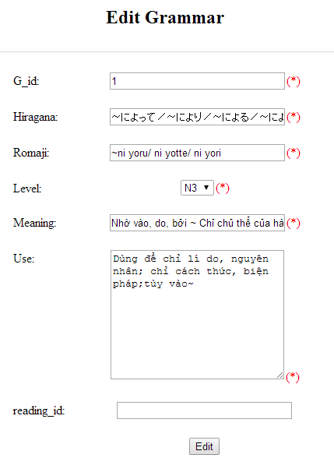

Figure 8.3: Edit grammar

Table 8.3: Edit vocabulary’s screen description:

|  |  |  |  |  |  |  |
| --- | --- | --- | --- | --- | --- | --- |
| No | Field name | Type | Require | Mandatory | Max-Length | Description |
| 1 | Hiragana | Text | Text | Y | 200 | Admin input grammar by hiragana with length less than 200 characters |
| 2 | Romaji | Text | Text | Y | 200 | Admin input grammar by romaji with length less than 200 characters |
| 3 | Meaning | Text | Text | Y | 200 | Admin input mean of grammar with length less than 200 characters |
| 4 | Use | Text | Text | Y | 1000 | Admin input use of grammar with length less than 1000 characters |
| 5 | Level | Drop-down list | Choose | Y |  | Admin choose level of grammar |
| 6 | Reading_id | Text | Text | Y | 20 | Admin input reading_id |
| 7 | Add | Button | Click | Y |  | Admin add new grammar |

|  |  |  |  |  |
| --- | --- | --- | --- | --- |
| **UC0030 - Specification** | | | | |
| **Use-case No.** | <UC0030> | **Use-case Version** | | <1.0> |
| **Use-case Name** | Edit grammar | | | |
| **Author** | Minh PT | | | |
| **Date** | 09/06/2014 | **Priority** | <High > | |
| **Actor:**  Admin  **Summary:**  When Administrator want to edit a grammatical structure in database which has some new meanings or errors. Admin will search that grammar then click “Edit” link. When edit finished, new meaning of that grammar will be updated.  **Triggers**  User must click on “Grammar management” then search for the grammatical structure. User click on “Edit” link corresponding with grammar which want to edit. User edit necessary information of grammar in the right fields then click on “Edit” button.  **Preconditions:**   * Website is available * User has to login as Administrator * All mandatory fields have been filled * All input data must be valid and have not existed in system   **Post Conditions:**  Changed information of grammar has been saved into system database successfully  **Main Success Scenario:**   |  |  |  | | --- | --- | --- | | **Step** | **User** | **System** | | 1 | Have logged into system as an admin |  | | 2 | Click on “Management grammar ” then search for the grammatical structure that they want to edit | Displays search result as a table | | 3 | Click on “Edit” link corresponding with grammar | Display “Edit Grammar” screen that contains the information of chosen grammar with these elements:   * G_hiragana * G_romaji * G_Meaning * G_Use * G_Example * G_Status | | 4 | Edit grammar information |  | | 5 | Click “Edit” button | The system validates the input data and then save data into database | | 5 | Click “Reset” button | The system clear all data in text fields and text area |     **Alternative Scenario:**   |  |  |  | | --- | --- | --- | | **At Step** | **User** | **System** | | 4 | Edit grammar information then click to another link | Do not save edited data then redirect to selected page |   **Exceptions:**   |  |  |  | | --- | --- | --- | | **At Step** | **User** | **System** | | 4 | Edit grammar information to be similar to another existed grammar |  | | 5 | Click “Edit” button | The system validates the input data and return Error message and do not save edited data into database |   **Reference:**  UC0028 - <Admin> Search Grammar | | | | |

##### UC0031: <Admin> Delete grammar

|  |  |  |  |  |
| --- | --- | --- | --- | --- |
| **UC0031 - Specification** | | | | |
| **Use-case No.** | <UC0031> | **Use-case Version** | | <1.0> |
| **Use-case Name** | Delete grammar | | | |
| **Author** | Minh PT | | | |
| **Date** | 09/06/2014 | **Priority** | <High > | |
| **Actor:**  Admin  **Summary:**  When Administrator want to delete a grammar in database. Admin will search that grammar then click “Delete” link. When deleted finished, that grammar no longer exist in database.  **Triggers**  User must click on “Grammar management” then search for the grammatical structure. User click on “Delete” link corresponding with grammar which want to delete.  **Preconditions:**   * Website is available * User has to login as Administrator   **Post Conditions:**  Grammar has been deleted from system database successfully  **Main Success Scenario:**   |  |  |  | | --- | --- | --- | | **Step** | **User** | **System** | | 1 | Have logged into system as an admin |  | | 2 | Click on “Grammar management ” then search for the grammar that they want to delete | Displays search result as a table | | 3 | Click on “Delete” link corresponding with grammar | Remove that grammar in database |   **Reference:** UC0028 - <Admin> Search grammar | | | | |
|  | | | | |

### Reading Document Management

#### Use case diagram

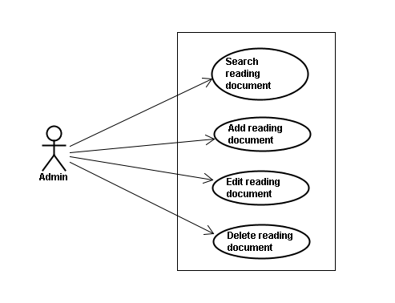

#### Use case specifications

Screen Description: This is Grammar Management screen. When admin want to do work with grammar database, admin have to log in. At here, Admin can manage grammar database by search grammatical structure, add new grammatical structure, edit grammatical structure and delete grammatical structure.

##### UC0032: <Admin> Search reading document

|  |  |  |  |  |
| --- | --- | --- | --- | --- |
| **UC0032 - Specification** | | | | |
| **Use-case No.** | <UC0032> | **Use-case Version** | | <1.0> |
| **Use-case Name** | Search document | | | |
| **Author** | Minh PT | | | |
| **Date** | 09/06/2014 | **Priority** | <High > | |
| **Actor:**  Admin  **Summary:**  When Administrator want to search reading document in database and Administrator can search reading document in database successfully if it is existed  **Triggers**  Click on “Reading management” tab, input name of reading document in the right text box then click “Search” button  **Preconditions:**  Input data must be correctly and User has to login as Administrator user  **Post Conditions:**  Display detail information of reading document  **Main Success Scenario:**   |  |  |  | | --- | --- | --- | | **Step** | **User** | **System** | | 1 | Have logged into system as an admin |  | | 2 | Click on “Reading management” tab | Displays criteria search screen | | 3 | Fill information of the reading document that they want to find into these fields then click “Search” button | Displays search result as a table with these elements:   * Serial number * Title * Content * Meaning * Edit * Delete |     **Alternative Scenario:**   |  |  |  | | --- | --- | --- | | **At Step** | **User** | **System** | | 3 | Fill information of the reading document that they want to find into these fields then click on another link | Switch to selected page |   **Exceptions:**   |  |  |  | | --- | --- | --- | | **At Step** | **User** | **System** | | 3 | Fill information of the reading document that they want to find (that do not exited in database) into these fields then click “Search” button | Return Error message to inform that reading document cannot be found | | | | | |

##### UC0033: <Admin> Add reading document

|  |  |  |  |  |
| --- | --- | --- | --- | --- |
| **UC0030 - Specification** | | | | |
| **Use-case No.** | <UC0030> | **Use-case Version** | | <1.0> |
| **Use-case Name** | Add document | | | |
| **Author** | Minh PT | | | |
| **Date** | 09/06/2014 | **Priority** | <High > | |
| **Actor:**  Admin  **Summary:**  When Administrator want to add new reading document into database. They have to insert all necessary data of reading document into “Add new reading” screen  **Triggers**  User must click on “Reading management/ Add new” tab and input all necessary information of grammar into the right fields then click on “Add new” button  **Preconditions:**   * User have logged into system as an admin. * All mandatory fields have been filled * All input data must be valid and have not existed in system   **Post Conditions:**  New reading document has been saved into system database successfully  **Main Success Scenario:**   |  |  |  | | --- | --- | --- | | **Step** | **User** | **System** | | 1 | Have logged into system as an admin |  | | 2 | Click on “Reading management/Add new” tab | Display “Add New Reading” screen that contains these elements:   * Title * Content * Meaning | | 3 | Fill reading document information into all necessary or mandatory fields |  | | 4 | Click “Add new” button | The system validates the input data and then save new reading document data into database |     **Alternative Scenario:**   |  |  |  | | --- | --- | --- | | **At Step** | **User** | **System** | | 4 | Click on another link | Do not save new reading document data into database then redirect to selected page |   **Exceptions:**   |  |  |  | | --- | --- | --- | | **At Step** | **User** | **System** | | 4 | Do not fill full information into fields then click “Add new” button | Return Error message beside empty field and ask if user want to add with empty field. | | | | | |

##### UC0034: <Admin> Edit reading document

|  |  |  |  |  |
| --- | --- | --- | --- | --- |
| **UC0034 - Specification** | | | | |
| **Use-case No.** | <UC0034> | **Use-case Version** | | <1.0> |
| **Use-case Name** | Edit reading document | | | |
| **Author** | Minh PT | | | |
| **Date** | 09/06/2014 | **Priority** | <High > | |
| **Actor:**  Admin  **Summary:**  When Administrator want to edit reading document on database which has some new meanings or errors  **Triggers**  User must click on “Reading management” then search for the reading document. User click on “Edit” link on corresponding reading document. They edit necessary information of reading document in the right fields then click on “Edit” button.  **Preconditions:**   * User have logged into system as an admin. * All mandatory fields have been filled * All input data must be valid and have not existed in system   **Post Conditions:**  Changed information of reading document has been saved into system database successfully  **Main Success Scenario:**   |  |  |  | | --- | --- | --- | | **Step** | **User** | **System** | | 1 | Have logged into system as an admin |  | | 2 | Click on “Reading management ” then search for the reading document that they want to edit | Displays search result as a table | | 3 | Click on “Edit” link | Display “Edit reading” screen that contains the information of chosen reading with these elements:   * Title * Content * Meaning | | 4 | Edit reading document information |  | | 5 | Click “Edit” button | The system validates the input data and then save data into database |     **Alternative Scenario:**   |  |  |  | | --- | --- | --- | | **At Step** | **User** | **System** | | 4 | Edit reading information then click to another link | Do not save edited data then redirect to selected page |   **Exceptions:**   |  |  |  | | --- | --- | --- | | **At Step** | **User** | **System** | | 4 | Edit reading information to be similar to another existed reading |  | | 5 | Click “Edit” button | The system validates the input data and return Error message and do not save edited data into database |  |   **Reference:**  UC0032- <Admin> Search reading document | | | | |

##### UC0035: <Admin> Delete reading document

|  |  |  |  |  |
| --- | --- | --- | --- | --- |
| **UC0035 - Specification** | | | | |
| **Use-case No.** | <UC0035> | **Use-case Version** | | <1.0> |
| **Use-case Name** | Delete reading document | | | |
| **Author** | Minh PT | | | |
| **Date** | 09/06/2014 | **Priority** | <High > | |
| **Actor:**  Admin  **Summary:**  When Administrator want to delete reading document on database  **Triggers**  User must click on “Reading management” then search for the reading document. User click on “Delete” link on corresponding reading document.  **Preconditions:**   * User have logged into system as an admin. * All mandatory fields have been filled * All input data must be valid and have existed in system   **Post Conditions:**  Reading document has been deleted from system database successfully  **Main Success Scenario:**   |  |  |  | | --- | --- | --- | | **Step** | **User** | **System** | | 1 | Have logged into system as an admin |  | | 2 | Click on “Reading management ” then search for the reading document that they want to delete | Displays search result as a table | | 3 | Click on “Delete” link beside that reading document row | Displays pop up to confirm if they really want to remove that reading document | | 4 | Click “Yes” button on popup | Closes the popup then remove that reading document name from reading list |     **Alternative Scenario:**   |  |  |  | | --- | --- | --- | | **At Step** | **User** | **System** | | 4 | Click close icon of the popup | Only closes the popup, does not remove that reading document |   **Exceptions:**   |  |  |  | | --- | --- | --- | | **At Step** | **User** | **System** | | 4 | Click “Cancel” button on popup | Only closes the popup, does not remove that reading document |   **Reference:**  UC0032 - <Admin> Search reading document | | | | |
|  | | | | |

### Conversation management

#### Use case diagram

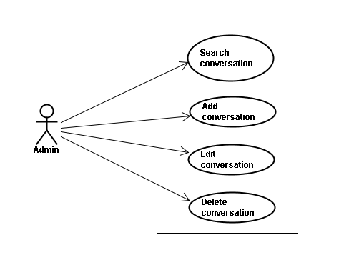

#### Screen description

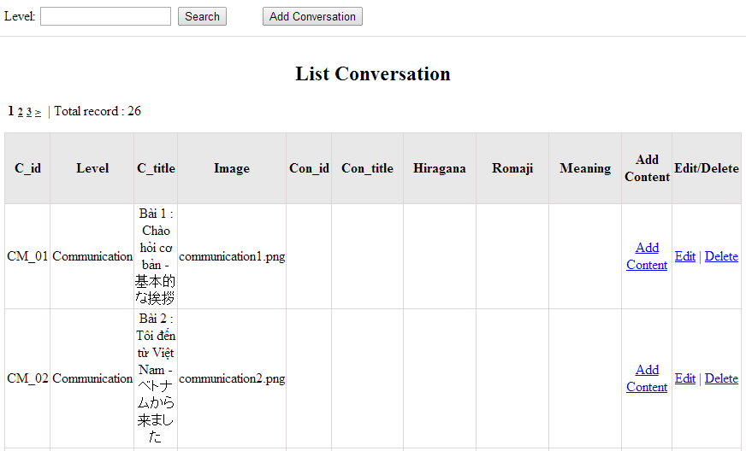

Figure 10: Conversation management

Table 10.1: Conversation management’s screen description:

|  |  |  |  |  |  |  |
| --- | --- | --- | --- | --- | --- | --- |
| No | Field name | Type | Require | Mandatory | Max-Length | Description |
| 1 | Level | Text | Text | Y | 100 | Admin input level with length less than 100 characters |
| 2 | Addnew | Button | Click | N |  | Admin add new conversation into database |
| 3 | Add content | Button | Click | Y |  | Admin input content of conversation |
| 4 | Edit | Button | Click | N |  | Admin click edit conversation |
| 5 | Delete | Button | Click | N |  | Admin click delete conversation |

#### Use case specifications

##### UC0036: <Admin> Search conversation

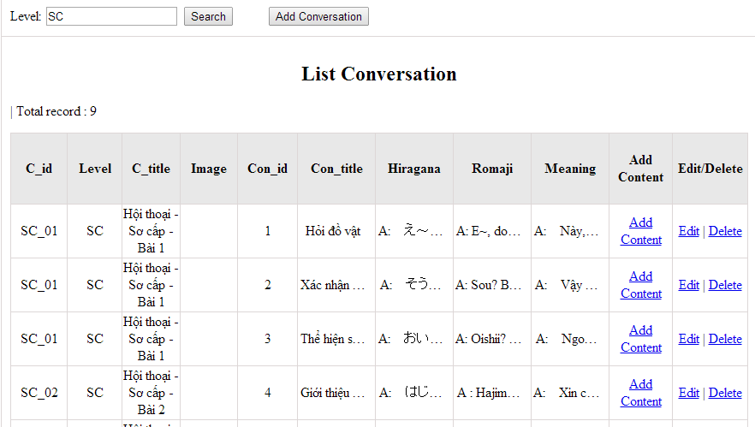

Figure 10.1: Search conversation

|  |  |  |  |  |
| --- | --- | --- | --- | --- |
| **UC0036 - Specification** | | | | |
| **Use-case No.** | <UC0036> | **Use-case Version** | | <1.0> |
| **Use-case Name** | Search conversation | | | |
| **Author** | Minh PT | | | |
| **Date** | 09/06/2014 | **Priority** | <High > | |
| **Actor:**  Admin  **Summary:**  When Administrator wants to search conversation in database. User input name of conversation or level then click “Search” button  **Triggers**  Click on “Conversation management” tab, input name of conversation in the right text box then click “Search” button  **Preconditions:**   * Website is available * User has to login as Administrator * User has to input data in search area   **Post Conditions:**  Display detail information of conversation  **Main Success Scenario:**   |  |  |  | | --- | --- | --- | | **Step** | **User** | **System** | | 1 | Have logged into system as an admin |  | | 2 | Click on “Conversation management” tab | Displays criteria search screen | | 3 | Fill information of the conversation that they want to find into fields: C_id or Level then click “Search” button | Displays search result as a table with these elements:   * C_id * Level * Title * Edit * Delete |     **Alternative Scenario:**   |  |  |  | | --- | --- | --- | | **At Step** | **User** | **System** | | 3 | Fill information of the conversation that they want to find into these fields then click on another link | Switch to selected page |   **Exceptions:**   |  |  |  | | --- | --- | --- | | **At Step** | **User** | **System** | | 3 | Fill information of the conversation that they want to find (that do not exited in database) into these fields then click “Search” button | Return Error message to inform that conversation cannot be found | | | | | |

##### UC0037: <Admin> Add conversation

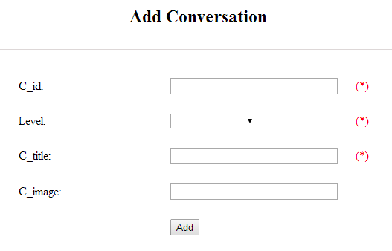

Figure 10.2.1: Add conversation

Table 10.2.1: Add conversation’s screen description:

|  |  |  |  |  |  |  |
| --- | --- | --- | --- | --- | --- | --- |
| No | Field name | Type | Require | Mandatory | Max-Length | Description |
| 1 | ID | Text | Text | Y | 10 | Admin input conversation’s ID with length less than 10 characters |
| 2 | Level | Drop-down list | Click | Y |  | Admin choose conversation’s |
| 3 | Title | Text | Text | Y | 1000 | Admin input title of conversation with length less than 1000 characters |
| 4 | Image | Text | Text | N | 200 | Admin input link of image |
| 5 | Add | Button | Click | Y |  | Admin add new conversation |

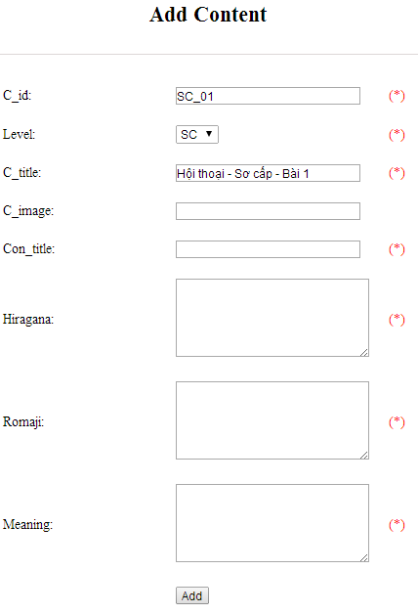

Figure 10.2.2: Add new conversation content

Table 10.2.2: Add conversation content’s screen description:

|  |  |  |  |  |  |  |
| --- | --- | --- | --- | --- | --- | --- |
| No | Field name | Type | Require | Mandatory | Max-Length | Description |
| 1 | Con_Title | Text | Text | Y | 200 | Admin input content title with length less than 200 characters |
| 2 | Hiragana | Text | Text | Y | 5000 | Admin input conversation by hiragana with length less than 5000 characters |
| 3 | Romaji | Text | Text | Y | 5000 | Admin input conversation by romaji with length less than 5000 characters |
| 4 | Meaning | Text | Text | Y | 5000 | Admin input conversation’s meaning with length less than 5000 characters |
| 5 | Add | Button | Click | Y |  | Admin add new conversation |

|  |  |  |  |  |
| --- | --- | --- | --- | --- |
| **UC0037 - Specification** | | | | |
| **Use-case No.** | <UC0037> | **Use-case Version** | | <1.0> |
| **Use-case Name** | Add conversation | | | |
| **Author** | Minh PT | | | |
| **Date** | 09/06/2014 | **Priority** | <High > | |
| **Actor:**  Admin  **Summary:**  When Administrator wants to add new conversation into database. They have to insert all necessary data of conversation into “Add Conversation” screen  **Triggers**  User must click on “Conversation management/ Add New” and input all necessary information of conversation into the right fields then click on “Add” button  **Preconditions:**   * Website is available * User have logged into system as an admin. * All mandatory fields have been filled * All input data must be valid and have not existed in system   **Post Conditions:**  New conversation has been saved into system database successfully  **Main Success Scenario:**   |  |  |  | | --- | --- | --- | | **Step** | **User** | **System** | | 1 | Have logged into system as an admin |  | | 2 | Click on “Conversation management/Add New” | Display “Add Conversation” screen that contains these elements:   * C_id * Level * Title | | 3 | Fill conversation information into all necessary or mandatory fields |  | | 4 | Click “Add” button | The system validates the input data and then save new conversation data into database | | 4 | Click “Reset” button | The system clear all data in text fields | | 5 | Click “Conversation Content Management\Add New” | Display “Add New Conversation Content” screen that contains these elements:   * C_id * Con_hiragana * Con_romaji * Con_meaning | | 6 | Fill conversation content information into all necessary or mandatory fields |  | | 7 | Click “Add” button | The system validates the input data and then save new conversation content data into database | | 7 | Click “Reset” button | The system clear all data in text fields | |  |  |  |     **Alternative Scenario:**   |  |  |  | | --- | --- | --- | | **At Step** | **User** | **System** | | 4 | Click on another link | Do not save new conversation data into database then redirect to selected page | | 7 | Click on another link | Do not save new content conversation data into database then redirect to selected page |   **Exceptions:**   |  |  |  | | --- | --- | --- | | **At Step** | **User** | **System** | | 4 | Do not fill full information into fields then click “Add” button | Return Error message and request user input data into all fields | | 7 | Do not fill full information into fields then click “Add” button | Return Error message and request user input data into all fields | | 8 | C_id (that do not exited in database then click “Add” button | Return Error message and request user create name of conversation first | | | | | |

##### UC0038: <Admin> Edit conversation

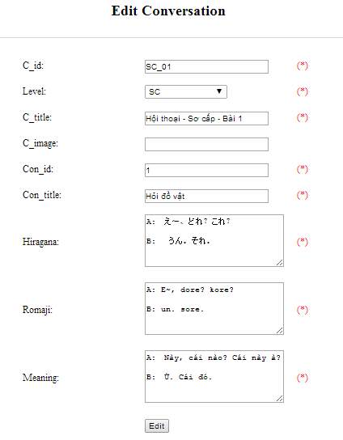

Figure 10.3.1: Edit conversation

Table 10.3.1: Edit conversation’s screen description

|  |  |  |  |  |  |  |
| --- | --- | --- | --- | --- | --- | --- |
| No | Field name | Type | Require | Mandatory | Max-Length | Description |
| 1 | Level | Text | Text | Y | 100 | Admin input conversation’s level with length less than 100 characters |
| 2 | Title | Text | Text | Y | 1000 | Admin input title of conversation with length less than 1000 characters |
| 3 | Image | Text | Text | N | 200 | Admin input link of image |
| 4 | Con_Title | Text | Text | Y | 200 | Admin input content title with length less than 200 characters |
| 5 | Hiragana | Text | Text | Y | 5000 | Admin input conversation by hiragana with length less than 5000 characters |
| 6 | Romaji | Text | Text | Y | 5000 | Admin input conversation by romaji with length less than 5000 characters |
| 7 | Meaning | Text | Text | Y | 5000 | Admin input conversation’s meaning with length less than 5000 characters |
| 8 | Edit | Button | Click | Y |  | Admin edit conversation |

|  |  |  |  |  |
| --- | --- | --- | --- | --- |
| **UC0038 - Specification** | | | | |
| **Use-case No.** | <UC0038> | **Use-case Version** | | <1.0> |
| **Use-case Name** | Edit conversation | | | |
| **Author** | Minh PT | | | |
| **Date** | 09/06/2014 | **Priority** | <High > | |
| **Actor:**  Admin  **Summary:**  When Administrator want to edit conversation in database which has some new meanings or errors. When edit finished, new meaning will be updated  **Triggers**  User must click on “Conversation management” then search for the conversation. User click on “Edit” link on corresponding conversation. They edit necessary information of conversation in the right fields then click on “Edit” button.  **Preconditions:**   * Website is available * User have logged into system as an admin. * All mandatory fields have been filled * All input data must be valid and have not existed in system   **Post Conditions:**  Changed information of conversation has been saved into system database successfully  **Main Success Scenario:**   |  |  |  | | --- | --- | --- | | **Step** | **User** | **System** | | 1 | Have logged into system as an admin |  | | 2 | Click on “Conversation management ” then search for the conversation that they want to edit | Displays search result as a table | | 3 | Click on “Edit” link corresponding | Display “Edit conversation” screen that contains the information of chosen conversation with these elements:   * C_id * Level * Title | | 4 | Edit conversation information |  | | 5 | Click “Edit” button | The system validates the input data and then save data into database | | 5 | Click “Reset” button | The system clear all data in text fields | | 6 | Click “Conversation Content Management” then search for the conversation content that they want to edit | Displays search result as a table | | 7 | Click on “Edit” link corresponding | Display “Edit Conversation Content” screen that contains the information of chosen conversation with these elements:   * C_id * Con_hiragana * Con_romaji * Con_meaning | | 8 | Edit conversation content information |  | | 9 | Click “Edit” button | The system validates the input data and then save data into database | | 9 | Click “Reset” button | The system clear all data in text fields |     **Alternative Scenario:**   |  |  |  | | --- | --- | --- | | **At Step** | **User** | **System** | | 4 | Edit conversation then click to another link | Do not save edited data then redirect to selected page | | 8 | Edit conversation content then click to another link | Do not save edited data then redirect to selected page |   **Exceptions:**   |  |  |  | | --- | --- | --- | | **At Step** | **User** | **System** | | 4 | Edit conversation to be similar to another existed conversation |  | | 5 | Click “Edit” button | The system validates the input data and return Error message and do not save edited data into database | | 8 | Edit conversation content to be similar to another existed conversation content |  | | 9 | Click “Edit” button | The system validates the input data and return Error message and do not save edited data into database |   **Reference:**  UC0036- <Admin> Search conversation | | | | |

##### UC0039: <Admin> Delete conversation

|  |  |  |  |  |
| --- | --- | --- | --- | --- |
| **UC0039 - Specification** | | | | |
| **Use-case No.** | <UC0039> | **Use-case Version** | | <1.0> |
| **Use-case Name** | Delete conversation | | | |
| **Author** | Minh PT | | | |
| **Date** | 09/06/2014 | **Priority** | <High > | |
| **Actor:**  Admin  **Summary:**  When Administrator want to delete conversation in database  **Triggers**  User must click on “Conversation management” then search for the conversation. User click on “Delete” link on corresponding conversation.  **Preconditions:**   * Website is available * User have logged into system as an admin.   **Post Conditions:**  Conversation has been deleted from system database successfully  **Main Success Scenario:**   |  |  |  | | --- | --- | --- | | **Step** | **User** | **System** | | 1 | Have logged into system as an admin |  | | 2 | Click on “Conversation management ” then search for the conversation that they want to delete | Displays search result as a table | | 3 | Click on “Delete” link corresponding with conversation | Remove that conversation in database |   **Exceptions:**   |  |  |  | | --- | --- | --- | | **At Step** | **User** | **System** | | 3 | Click on “Delete” link corresponding with conversation (conversation content is existing) | Return Error message and request user remove conversation content first |   **Reference:**  UC0036 - <Admin> Search conversation | | | | |
|  | | | | |

### Video Management

#### Use case diagram

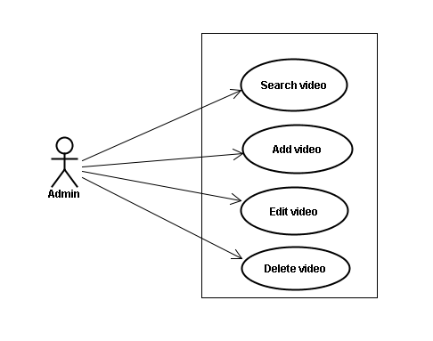

#### Screen description

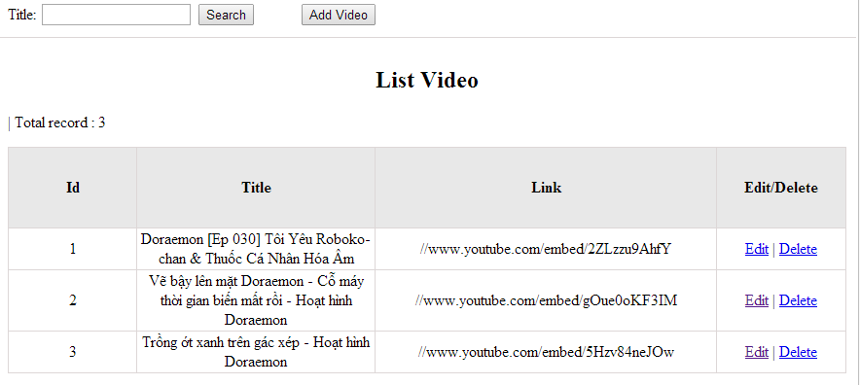

Figrure 11: Video management

Table 11.1: Video management’s screen description:

|  |  |  |  |  |  |  |
| --- | --- | --- | --- | --- | --- | --- |
| No | Field name | Type | Require | Mandatory | Max-Length | Description |
| 1 | Title | Text | Text | Y | 100 | Admin input title with length less than 100 character |
| 2 | Addnew | Button | Click | N |  | Admin add new video into database |
| 3 | Edit | Button | Click | N |  | Admin click edit video |
| 4 | Delete | Button | Click | N |  | Admin click delete video |

#### Use case specifications

##### UC040 <Video management>: Search video

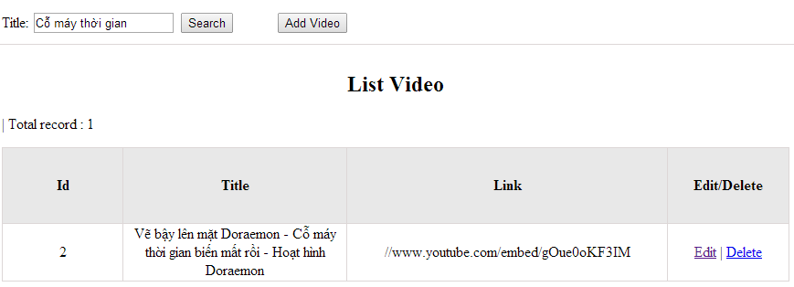

Figure 11.1: Search video

|  |  |  |  |  |
| --- | --- | --- | --- | --- |
| **UC0040 - Specification** | | | | |
| **Use-case No.** | <UC0040> | **Use-case Version** | | <1.0> |
| **Use-case Name** | Search video | | | |
| **Author** | Minh PT | | | |
| **Date** | 09/06/2014 | **Priority** | <High > | |
| **Actor:**  Admin  **Summary:**  When Administrator wants to search video in database. User input name of video then click “Search” button  **Triggers**  Click on “Video management” tab, input name of video in the right text box then click “Search” button  **Preconditions:**   * Website is available * User has to login as Administrator * User has to input data in search area   **Post Conditions:**  Display detail information of video  **Main Success Scenario:**   |  |  |  | | --- | --- | --- | | **Step** | **User** | **System** | | 1 | Have logged into system as an admin |  | | 2 | Click on “Video management” tab | Displays criteria search screen | | 3 | Fill information of the video that they want to find into these fields then click “Search” button | Displays search result as a table with these elements:   * Video ID * Vi_Title * Vi_Link * Edit * Delete |     **Alternative Scenario:**   |  |  |  | | --- | --- | --- | | **At Step** | **User** | **System** | | 3 | Fill information of the video that they want to find into these fields then click on another link | Switch to selected page |   **Exceptions:**   |  |  |  | | --- | --- | --- | | **At Step** | **User** | **System** | | 3 | Fill information of the video that they want to find (that do not exited in database) into these fields then click “Search” button | Return Error message to inform that video cannot be found | | | | | |

##### UC041 <Video management>: Add video

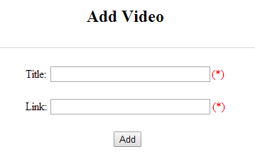

Figure 11.2: Add video

Table 11.2: Add video’s screen description:

|  |  |  |  |  |  |  |
| --- | --- | --- | --- | --- | --- | --- |
| No | Field name | Type | Require | Mandatory | Max-Length | Description |
| 1 | Title | Text | Text | Y | 200 | Admin input title with length less than 200 characters |
| 2 | Link | Text | Text | Y |  | Admin input hyperlink |
| 3 | Add | Button | Click | Y |  | Admin add new video |
| 4 | Reset | Button | Click | N |  | Admin reset information |

|  |  |  |  |  |
| --- | --- | --- | --- | --- |
| **UC0041 - Specification** | | | | |
| **Use-case No.** | <UC0041> | **Use-case Version** | | <1.0> |
| **Use-case Name** | Add video | | | |
| **Author** | Minh PT | | | |
| **Date** | 09/06/2014 | **Priority** | <High > | |
| **Actor:**  Admin  **Summary:**  When Administrator wants to add new video into database. They have to insert all necessary data of video into “Add Video” screen  **Triggers**  User must click on “Video management/ Add New” tab and input all necessary information of video into the right fields then click on “Add” button  **Preconditions:**   * Website is available * User have logged into system as an admin. * All mandatory fields have been filled * All input data must be valid and have not existed in system   **Post Conditions:**  New video has been saved into system database successfully  **Main Success Scenario:**   |  |  |  | | --- | --- | --- | | **Step** | **User** | **System** | | 1 | Have logged into system as an admin |  | | 2 | Click on “Video management/Add New” tab | Display “Add Video” screen that contains these elements:   * Vi_Title * Vi_Link | | 3 | Fill video information into all necessary or mandatory fields |  | | 4 | Click “Add” button | The system validates the input data and then save new video data into database | | 4 | Click “Reset” button | The system clear all data in text fields |     **Alternative Scenario:**   |  |  |  | | --- | --- | --- | | **At Step** | **User** | **System** | | 4 | Click on another link | Do not save new video data into database then redirect to selected page |   **Exceptions:**   |  |  |  | | --- | --- | --- | | **At Step** | **User** | **System** | | 4 | Do not fill full information into fields then click “Add” button | Return Error message and request user input data into all fields | | | | | |

##### UC042 <Video management>: Edit video

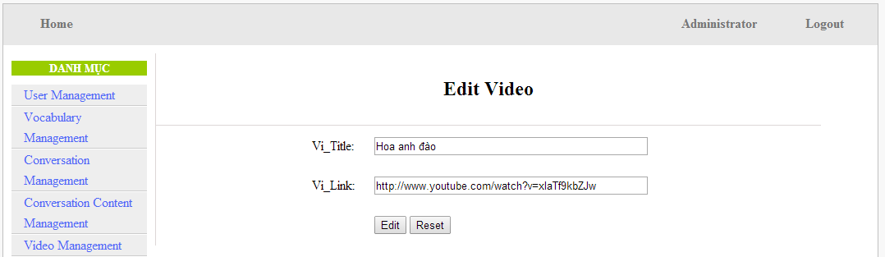

Figure 11.3: Edit video

Table 11.3: Edit video’s screen description:

|  |  |  |  |  |  |  |
| --- | --- | --- | --- | --- | --- | --- |
| No | Field name | Type | Require | Mandatory | Max-Length | Description |
| 1 | Title | Text | Text | Y | 200 | Admin input title with length less than 200 characters |
| 2 | Link | Text | Text | Y | 1000 | Admin input hyperlink |
| 3 | Add | Button | Click | Y |  | Admin edit video |

|  |  |  |  |  |
| --- | --- | --- | --- | --- |
| **UC0042 - Specification** | | | | |
| **Use-case No.** | <UC0042> | **Use-case Version** | | <1.0> |
| **Use-case Name** | Edit video | | | |
| **Author** | Minh PT | | | |
| **Date** | 09/06/2014 | **Priority** | <High > | |
| **Actor:**  Admin  **Summary:**  When Administrator wants to edit video in database which has some new meanings or errors. When edit finished, new meaning will be updated  **Triggers**  User must click on “Video management” then search for the video. User click on “Edit” link corresponding with video. User edit necessary information of video in the right fields then click on “Edit” button.  **Preconditions:**   * Website is available * User have logged into system as an admin. * All mandatory fields have been filled * All input data must be valid and have not existed in system   **Post Conditions:**  Changed information of video has been saved into system database successfully  **Main Success Scenario:**   |  |  |  | | --- | --- | --- | | **Step** | **User** | **System** | | 1 | Have logged into system as an admin |  | | 2 | Click on “Video management ” then search for the video that they want to edit | Displays search result as a table | | 3 | Click on “Edit” link corresponding | Display “Edit video” screen that contains the information of chosen video with these elements:   * Vi_Title * Vi_Link | | 4 | Edit video information |  | | 5 | Click “Edit” button | The system validates the input data and then save data into database | | 5 | Click “Reset” button | The system clear all data in text fields |     **Alternative Scenario:**   |  |  |  | | --- | --- | --- | | **At Step** | **User** | **System** | | 4 | Edit video then click to another link | Do not save edited data then redirect to selected page |   **Exceptions:**   |  |  |  | | --- | --- | --- | | **At Step** | **User** | **System** | | 4 | Edit video to be similar to another existed video |  | | 5 | Click “Edit” button | The system validates the input data and return Error message and do not save edited data into database |  |   **Reference:**  UC0040- <Admin> Search video | | | | |

##### UC043 <Video management>: Delete video

|  |  |  |  |  |
| --- | --- | --- | --- | --- |
| **UC0043 - Specification** | | | | |
| **Use-case No.** | <UC0043> | **Use-case Version** | | <1.0> |
| **Use-case Name** | Delete video | | | |
| **Author** | Minh PT | | | |
| **Date** | 09/06/2014 | **Priority** | <High > | |
| **Actor:**  Admin  **Summary:**  When Administrator wants to delete video in database  **Triggers**  User must click on “Video management” then search for the video. User click on “Delete” link on corresponding video.  **Preconditions:**   * Website is available * User have logged into system as an admin.   **Post Conditions:**  Video has been deleted from system database successfully  **Main Success Scenario:**   |  |  |  | | --- | --- | --- | | **Step** | **User** | **System** | | 1 | Have logged into system as an admin |  | | 2 | Click on “Video management ” then search for the video that they want to delete | Displays search result as a table | | 3 | Click on “Delete” link corresponding with conversation | Remove that video in database |     **Reference:**  UC0040 - <Admin> Search video | | | | |
|  | | | | |

### Listening Article Management

#### Use case diagram

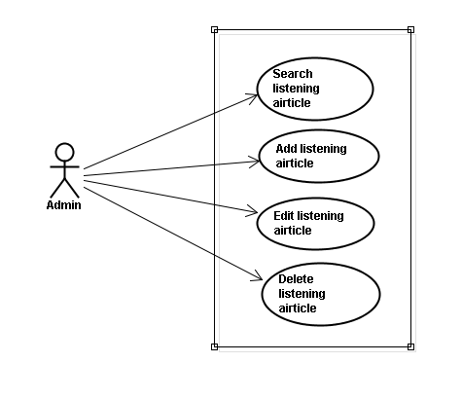

#### Screen description

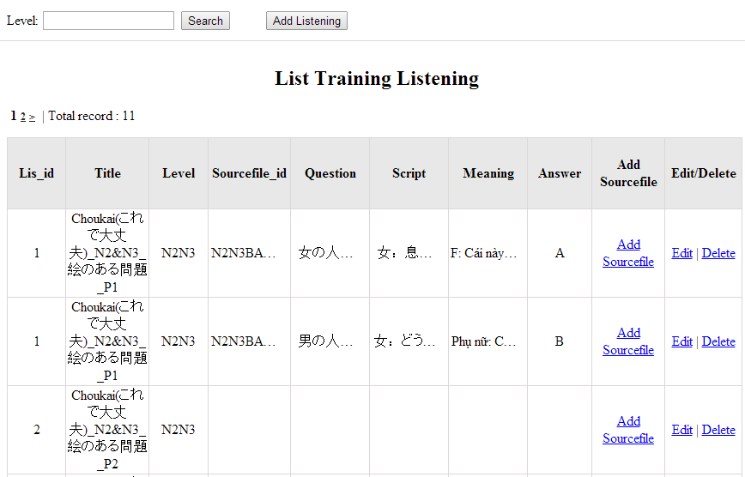

Figure 12: Listening article management

Table 12.1: Conversation management’s screen description:

|  |  |  |  |  |  |  |
| --- | --- | --- | --- | --- | --- | --- |
| No | Field name | Type | Require | Mandatory | Max-Length | Description |
| 1 | Level | Text | Text | Y | 100 | Admin input level with length less than 100 characters |
| 2 | Addnew | Button | Click | N |  | Admin add new listening article into database |
| 3 | Add source | Button | Click | Y |  | Admin input source file |
| 4 | Edit | Button | Click | N |  | Admin click edit listening article |
| 5 | Delete | Button | Click | N |  | Admin click delete article |

#### Use case specifications

##### UC044 <Listening Article Management>: Search listening article

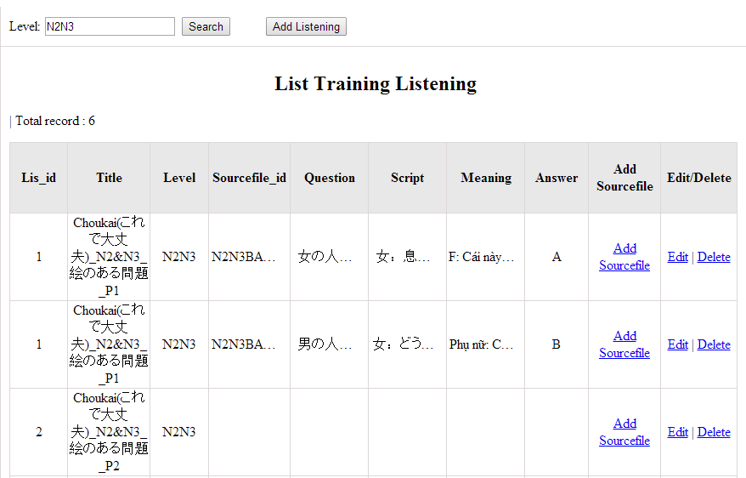

Figure 12.1: Search listening article

|  |  |  |  |  |
| --- | --- | --- | --- | --- |
| **UC0044 - Specification** | | | | |
| **Use-case No.** | <UC0044> | **Use-case Version** | | <1.0> |
| **Use-case Name** | Search listening article | | | |
| **Author** | Minh PT | | | |
| **Date** | 09/06/2014 | **Priority** | <High > | |
| **Actor:**  Admin  **Summary:**  When Administrator wants to search listening article in database. User input listening id or listening level then click “Search” button  **Triggers**  Click on “Listening practice management” tab, input listening id or level in the right text box then click “Search” button  **Preconditions:**   * Website is available * User has to login as Administrator * User has to input data in search area   **Post Conditions:**  Display detail information of listening article  **Main Success Scenario:**   |  |  |  | | --- | --- | --- | | **Step** | **User** | **System** | | 1 | Have logged into system as an admin |  | | 2 | Click on “Listening article management” tab | Displays criteria search screen | | 3 | Fill information of the listening article that they want to find into lis_id or lis_level then click “Search” button | Displays search result as a table with these elements:   * Lis_id * Lis_level * Edit * Delete |     **Alternative Scenario:**   |  |  |  | | --- | --- | --- | | **At Step** | **User** | **System** | | 3 | Fill information of the listening article that they want to find into these fields then click on another link | Switch to selected page |   **Exceptions:**   |  |  |  | | --- | --- | --- | | **At Step** | **User** | **System** | | 3 | Fill information of the listening article that they want to find (that do not exited in database) into these fields then click “Search” button | Return Error message to inform that listening article cannot be found | | | | | |

##### UC045 <Listening Article Management>: Add listening article

Add listening screen:

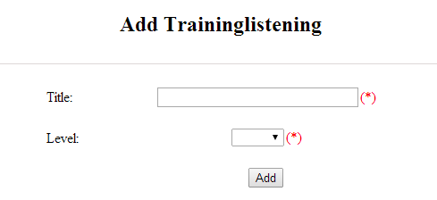

Figure 12.2: Add listening :

Table 12.2: Add listening article’s screen description:

|  |  |  |  |  |  |  |
| --- | --- | --- | --- | --- | --- | --- |
| No | Field name | Type | Require | Mandatory | Max-Length | Description |
| 1 | Title | Text | Text | Y | 500 | Admin input id with length less than 500 characters |
| 2 | Level | Drop-down list | Choose | Y |  | Admin choose level |
| 3 | Add | Button | Click | Y |  | Admin add new listening |

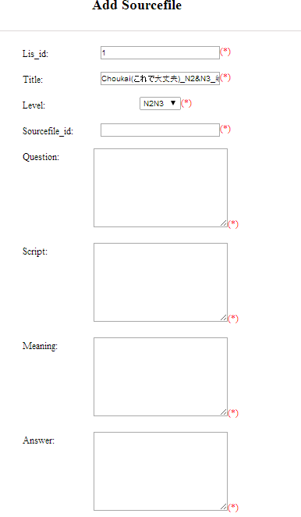

Figure 12.2.1: Add listening source file:

Table 12.2.1: Add listening source file’s screen description:

|  |  |  |  |  |  |  |
| --- | --- | --- | --- | --- | --- | --- |
| No | Field name | Type | Require | Mandatory | Max-Length | Description |
| 1 | Source_ID | Text | Text | Y | 100 | Admin input id with length less than 100 characters |
| 2 | Question | Text | Text | Y | 5000 | Admin input question of listening with length less than 5000 characters |
| 3 | Script | Text | Text | Y | 5000 | Admin input script of listening with length less than 5000 characters |
| 4 | Meaning | Text | Text | Y | 5000 | Admin input meaning of listening with length less than 5000 characters |
| 5 | Answer | Text | Text | Y | 5000 | Admin input answer of listening with length less than 5000 characters |
| 6 | Add | Button | Click | Y |  | Admin add source file |

|  |  |  |  |  |
| --- | --- | --- | --- | --- |
| **UC0045 - Specification** | | | | |
| **Use-case No.** | <UC0045> | **Use-case Version** | | <1.0> |
| **Use-case Name** | Add listening article | | | |
| **Author** | Minh PT | | | |
| **Date** | 09/06/2014 | **Priority** | <High > | |
| **Actor:**  Admin  **Summary:**  When Administrator wants to add new listening article into database. They have to insert all necessary data of listening article into “Add new listening” screen  **Triggers**  User must click on “Listening management/ Add New” and input all necessary information of listening article into the right fields then click on “Add” button  **Preconditions:**   * Website is available * User have logged into system as an admin. * All mandatory fields have been filled * All input data must be valid and have not existed in system   **Post Conditions:**  New listening article has been saved into system database successfully  **Main Success Scenario:**   |  |  |  | | --- | --- | --- | | **Step** | **User** | **System** | | 1 | Have logged into system as an admin |  | | 2 | Click on “Listening article management/Add New” | Display “Add New Listening” screen that contains these elements:   * Lis_id * Lis_level | | 3 | Fill listening article information into all necessary or mandatory fields |  | | 4 | Click “Add” button | The system validates the input data and then save new listening article data into database |     **Alternative Scenario:**   |  |  |  | | --- | --- | --- | | **At Step** | **User** | **System** | | 4 | Click on another link | Do not save new listening article data into database then redirect to selected page |   **Exceptions:**   |  |  |  | | --- | --- | --- | | **At Step** | **User** | **System** | | 4 | Do not fill full information into fields then click “Add” button | Return Error message and request user input data into all fields | | | | | |

##### UC046 <Listening Article Management>: Edit listening article



Figure 12.3: Edit listening content:

Table 12.3: Edit listening article’s screen description:

|  |  |  |  |  |  |  |
| --- | --- | --- | --- | --- | --- | --- |
| No | Field name | Type | Require | Mandatory | Max-Length | Description |
| 1 | ID | Text | Text | Y | 100 | Admin input id with length less than 100 characters |
| 2 | Level | Drop-down list | Choose | Y |  | Admin choose level |
| 3 | Source_ID | Text | Text | Y | 100 | Admin input id with length less than 100 characters |
| 4 | Question | Text | Text | Y | 5000 | Admin input question of listening with length less than 5000 characters |
| 5 | Script | Text | Text | Y | 5000 | Admin input script of listening with length less than 5000 characters |
| 6 | Meaning | Text | Text | Y | 5000 | Admin input meaning of listening with length less than 5000 characters |
| 7 | Answer | Text | Text | Y | 5000 | Admin input answer of listening with length less than 5000 characters |
| 8 | Edit | Button | Click | Y |  | Admin edit listening |

|  |  |  |  |  |
| --- | --- | --- | --- | --- |
| **UC0046 - Specification** | | | | |
| **Use-case No.** | <UC0046> | **Use-case Version** | | <1.0> |
| **Use-case Name** | Edit listening article | | | |
| **Author** | Minh PT | | | |
| **Date** | 09/06/2014 | **Priority** | <High > | |
| **Actor:**  Admin  **Summary:**  When Administrator wants to edit listening article in database which has some new meanings or errors. When edit finished, new meaning will be updated  **Triggers**  User must click on “Listening management” then search for the listening article. User click on “Edit” link corresponding with listening article. They edit necessary information of listening article in the right fields then click on “Edit” button.  **Preconditions:**   * Website is available * User have logged into system as an admin. * All mandatory fields have been filled * All input data must be valid and have not existed in system   **Post Conditions:**  Changed information of listening article has been saved into system database successfully  **Main Success Scenario:**   |  |  |  | | --- | --- | --- | | **Step** | **User** | **System** | | 1 | Have logged into system as an admin |  | | 2 | Click on “Trainig listening” then search for the listening article that they want to edit | Displays search result as a table | | 3 | Click on “Edit” link corresponding | Display “Edit listening” screen that contains the information of chosen listening article with these elements:   * Lis_id * Lis_level | | 4 | Edit listening article information |  | | 5 | Click “Edit” button | The system validates the input data and then save data into database |     **Alternative Scenario:**   |  |  |  | | --- | --- | --- | | **At Step** | **User** | **System** | | 4 | Edit listening article then click to another link | Do not save edited data then redirect to selected page |   **Exceptions:**   |  |  |  | | --- | --- | --- | | **At Step** | **User** | **System** | | 4 | Edit listening article to be similar to another existed listening article |  | | 5 | Click “Edit” button | The system validates the input data and return Error message and do not save edited data into database |  |   **Reference:**  UC0044- <Admin> Search listening article | | | | |

##### UC047 <Listening Article Management>: Delete listening article

|  |  |  |  |  |
| --- | --- | --- | --- | --- |
| **UC0047 - Specification** | | | | |
| **Use-case No.** | <UC0047> | **Use-case Version** | | <1.0> |
| **Use-case Name** | Delete listening article | | | |
| **Author** | Minh PT | | | |
| **Date** | 09/06/2014 | **Priority** | <High > | |
| **Actor:**  Admin  **Summary:**  When Administrator want to delete listening article inn database  **Triggers**  User must click on “Listening article management” then search for the listening article. User click on “Delete” link corresponding with listening article.  **Preconditions:**   * Website is available * User have logged into system as an admin.   **Post Conditions:**  Listening article has been deleted from system database successfully  **Main Success Scenario:**   |  |  |  | | --- | --- | --- | | **Step** | **User** | **System** | | 1 | Have logged into system as an admin |  | | 2 | Click on “Listening article management ” then search for the listening article that they want to delete | Displays search result as a table | | 3 | Click on “Delete” link corresponding | Remove that listening article in database |     **Reference:**  UC0044 - <Admin> Search listening article | | | | |
|  | | | | |

### Test management

#### Use case diagram

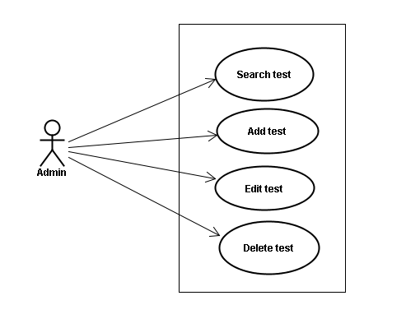

#### Screen description

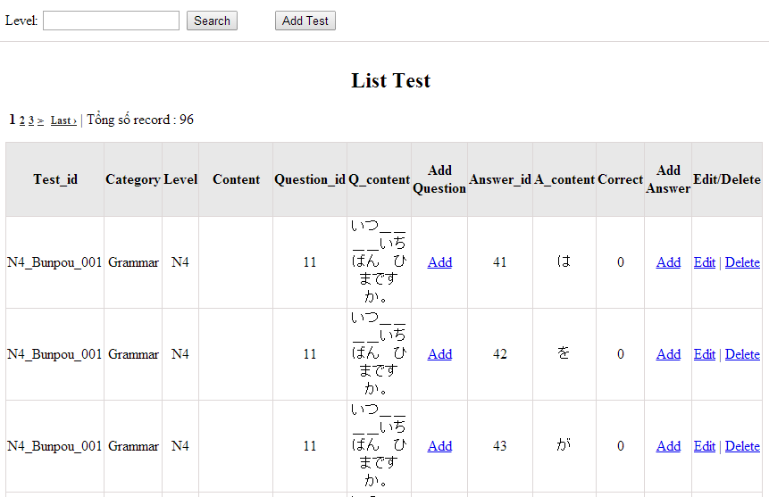

Figure 13: Doing test management

Table 13.1: Doing test management’s screen description:

|  |  |  |  |  |  |  |
| --- | --- | --- | --- | --- | --- | --- |
| No | Field name | Type | Require | Mandatory | Max-Length | Description |
| 1 | Level | Text | Text | Y | 100 | Admin input level |
| 2 | Add new test | Button | Click | N |  | Admin add new test into database |
| 3 | Add question | Button | Click | N |  | Admin add question |
| 4 | Add answer | Button | Click | N |  | Admin add answer |
| 4 | Edit | Button | Click | N |  | Admin click edit test |
| 5 | Delete | Button | Click | N |  | Admin click delete test |

#### Use case specifications

##### UC048 <Test management>: Search test

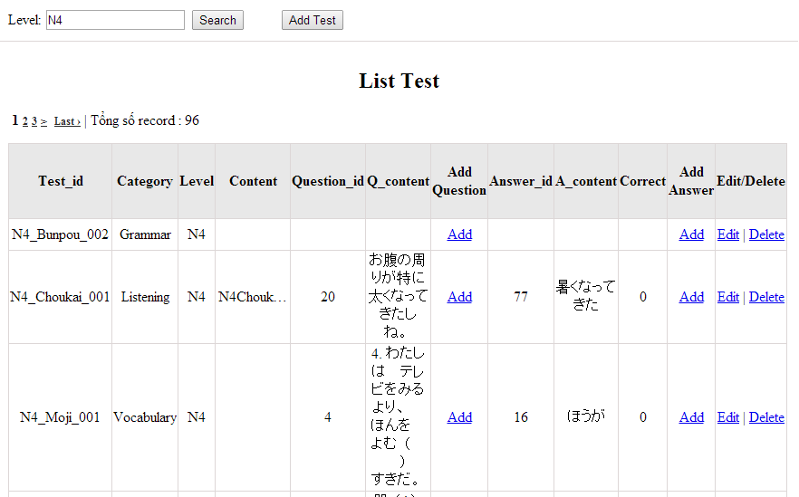

Figure 13.1: Search test:

|  |  |  |  |  |
| --- | --- | --- | --- | --- |
| **UC0048 - Specification** | | | | |
| **Use-case No.** | <UC0048> | **Use-case Version** | | <1.0> |
| **Use-case Name** | Search test | | | |
| **Author** | Minh PT | | | |
| **Date** | 09/06/2014 | **Priority** | <High > | |
| **Actor:**  Admin  **Summary:**  When Administrator wants to search test article in database. User input test id or test category then click “Search” button.  **Triggers**  Click on “Test management” tab, input Test_id or test_ in the right text box then click “Search” button  **Preconditions:**   * Website is available * User has to login as Administrator * User has to input data in search area   **Post Conditions:**  Display detail information of that test  **Main Success Scenario:**   |  |  |  | | --- | --- | --- | | **Step** | **User** | **System** | | 1 | Have logged into system as an admin |  | | 2 | Click on “Test management” tab | Displays criteria search screen | | 3 | Fill information of the test that they want to find into test_id or test_catagory then click “Search” button | Displays search result as a table with these elements:   * Test_id * Test_category * Edit * Delete |     **Alternative Scenario:**   |  |  |  | | --- | --- | --- | | **At Step** | **User** | **System** | | 3 | Fill information of the test that they want to find into these fields then click on another link | Switch to selected page |   **Exceptions:**   |  |  |  | | --- | --- | --- | | **At Step** | **User** | **System** | | 3 | Fill information of the test that they want to find (that do not exited in database) into these fields then click “Search” button | Return Error message to inform that test cannot be found | | | | | |

##### UC049 <Test management>: Add test

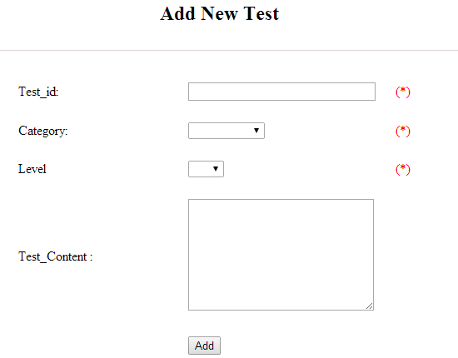

Figure 13.2: Add test

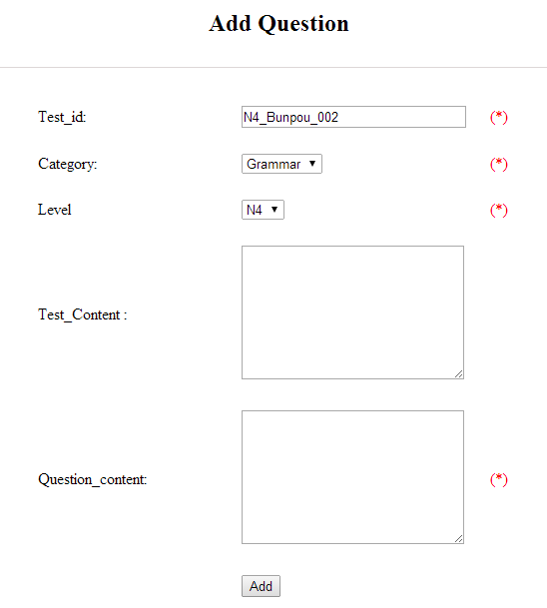

Figure 13.2.1: Add question

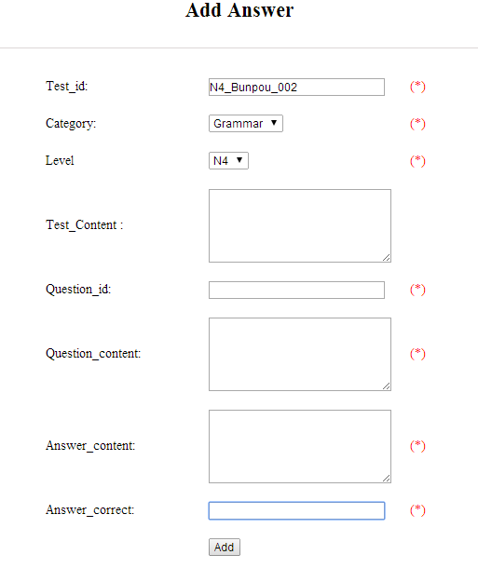

Figure 13.2.2: Add answer

Table 13.2: Add test & add question, add answer’s screen description:

|  |  |  |  |  |  |  |
| --- | --- | --- | --- | --- | --- | --- |
| No | Field name | Type | Require | Mandatory | Max-Length | Description |
| 1 | ID | Text | Text | Y | 100 | Admin input id with length less than 100 characters |
| 2 | Category | Drop-down list | Click | Y |  | Admin choose category |
| 3 | Level | Drop-down list | Click | Y |  | Admin choose level of test |
| 4 | Test content | Text | Text | Y | 5000 | Admin input content with length less than 5000 characters |
| 5 | Question_content | Text | Text | Y | 200 | Admin input question content with length less than 200 characters |
| 6 | Answer_content | Text | Text | Y | 200 | Admin input answer content with length less than 200 characters |
| 7 | Answer_correct | Text | Text | Y | 11 | Admin input answer correct with length less than 11 characters |
| 8 | Add | Button | Click | Y |  | Admin add new test |

|  |  |  |  |  |
| --- | --- | --- | --- | --- |
| **UC0049 - Specification** | | | | |
| **Use-case No.** | <UC0049> | **Use-case Version** | | <1.0> |
| **Use-case Name** | Add test | | | |
| **Author** | Minh PT | | | |
| **Date** | 09/06/2014 | **Priority** | <High > | |
| **Actor:**  Admin  **Summary:**  When Administrator want to add new test into database. They have to insert all necessary data of test into “Add new test” screen  **Triggers**  User must click on “Test management/ Add New” and input all necessary information of test into the right fields then click on “Add” button  **Preconditions:**   * Website is available * User have logged into system as an admin. * All mandatory fields have been filled * All input data must be valid and have not existed in system   **Post Conditions:**  New test has been saved into system database successfully  **Main Success Scenario:**   |  |  |  | | --- | --- | --- | | **Step** | **User** | **System** | | 1 | Have logged into system as an admin |  | | 2 | Click on “Test management/Add New” | Display “Add New Test” screen that contains these elements:   * Test_id * Test_category | | 3 | Fill test information into all necessary or mandatory fields |  | | 4 | Click “Add” button | The system validates the input data and then save new test data into database |     **Alternative Scenario:**   |  |  |  | | --- | --- | --- | | **At Step** | **User** | **System** | | 4 | Click on another link | Do not save new test data into database then redirect to selected page |   **Exceptions:**   |  |  |  | | --- | --- | --- | | **At Step** | **User** | **System** | | 4 | Do not fill full information into fields then click “Add” button | Return Error message and request user input data into all fields | | | | | |

##### UC050 <Test management>: Edit test

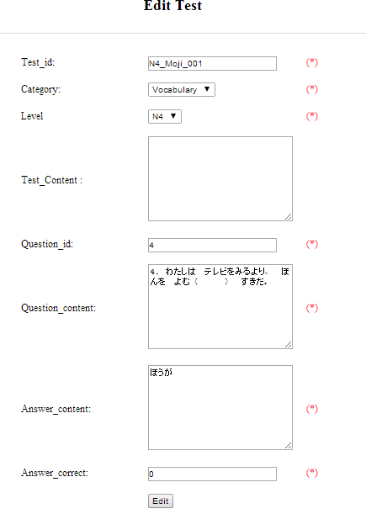

Figure 13.3: Edit test

Table 13.3: Edit test’s screen description:

|  |  |  |  |  |  |  |
| --- | --- | --- | --- | --- | --- | --- |
| No | Field name | Type | Require | Mandatory | Max-Length | Description |
| 1 | ID | Text | Text | Y | 100 | Admin input id with length less than 100 characters |
| 2 | Category | Drop-down list | Click | Y |  | Admin choose category |
| 3 | Level | Drop-down list | Click | Y |  | Admin choose level of test |
| 4 | Test content | Text | Text | Y | 5000 | Admin input content with length less than 5000 characters |
| 5 | Question_content | Text | Text | Y | 200 | Admin input question content with length less than 200 characters |
| 6 | Answer_content | Text | Text | Y | 200 | Admin input answer content with length less than 200 characters |
| 7 | Answer_correct | Text | Text | Y | 11 | Admin input answer correct with length less than 11 characters |
| 8 | Edit | Button | Click | Y |  | Admin edit test |

|  |  |  |  |  |
| --- | --- | --- | --- | --- |
| **UC0050 - Specification** | | | | |
| **Use-case No.** | <UC0050> | **Use-case Version** | | <1.0> |
| **Use-case Name** | Edit test | | | |
| **Author** | Minh PT | | | |
| **Date** | 09/06/2014 | **Priority** | <High > | |
| **Actor:**  Admin  **Summary:**  When Administrator want to edit test in database which has some new meanings or errors. When edit finished, new meaning will be updated  **Triggers**  User must click on “Test management” then search for the test. User click on “Edit” link on corresponding test. User edit necessary information of test in the right fields then click on “Edit” button.  **Preconditions:**   * Website is available * User have logged into system as an admin. * All mandatory fields have been filled * All input data must be valid and have not existed in system   **Post Conditions:**  Changed information of test has been saved into system database successfully  **Main Success Scenario:**   |  |  |  | | --- | --- | --- | | **Step** | **User** | **System** | | 1 | Have logged into system as an admin |  | | 2 | Click on “Test management ” then search for the test that they want to edit | Displays search result as a table | | 3 | Click on “Edit” link corresponding | Display “Edit Test” screen that contains the information of chosen test with these elements:   * Test_id * Test_category | | 4 | Edit test information |  | | 5 | Click “Edit” button | The system validates the input data and then save data into database | | 5 | Click “Reset” button | The system clear all data in text fields |     **Alternative Scenario:**   |  |  |  | | --- | --- | --- | | **At Step** | **User** | **System** | | 4 | Edit test then click to another link | Do not save edited data then redirect to selected page |   **Exceptions:**   |  |  |  | | --- | --- | --- | | **At Step** | **User** | **System** | | 4 | Edit test to be similar to another existed test |  | | 5 | Click “Edit” button | The system validates the input data and return Error message and do not save edited data into database |  |   **Reference:**  UC0048- <Admin> Search test | | | | |

##### UC051 <Test management>: Delete test

|  |  |  |  |  |
| --- | --- | --- | --- | --- |
| **UC0051 - Specification** | | | | |
| **Use-case No.** | <UC0051> | **Use-case Version** | | <1.0> |
| **Use-case Name** | Delete test | | | |
| **Author** | Minh PT | | | |
| **Date** | 09/06/2014 | **Priority** | <High > | |
| **Actor:**  Admin  **Summary:**  When Administrator want to delete test in database  **Triggers**  User must click on “Test management” then search for the test. User click on “Delete” link corresponding with test.  **Preconditions:**   * Website is available * User have logged into system as an admin.   **Post Conditions:**  Test has been deleted from system database successfully  **Main Success Scenario:**   |  |  |  | | --- | --- | --- | | **Step** | **User** | **System** | | 1 | Have logged into system as an admin |  | | 2 | Click on “Test management ” then search for the test that they want to delete | Displays search result as a table | | 3 | Click on “Delete” link corresponding | Remove that test in database |     **Reference:**  UC0048 - <Admin> Search test | | | | |
|  | | | | |

### Contributed content management

#### Use case diagram

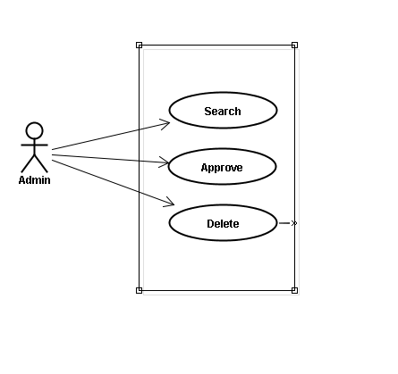

#### Use case specifications

##### UC052 <Contact’s content Management>: Search contribute content

Search contribute content screen:

1. Contribute kanji screen:

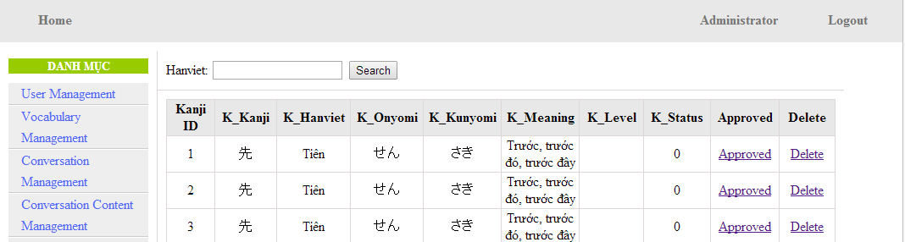

Figure 14.1: Contribute kanji’s screen

Table 14.1: Contribute kanji’s screen description:

|  |  |  |  |  |  |  |
| --- | --- | --- | --- | --- | --- | --- |
| No | Field name | Type | Require | Mandatory | Max-Length | Description |
| 1 | HanViet | Text | Text | Y | 100 | Admin input to search |
| 2 | Approved | Button | Click | N |  | Admin click to approved contribute |
| 3 | Delete | Button | Click | N |  | Admin click delete contribute |

1. Contribute grammar screen:

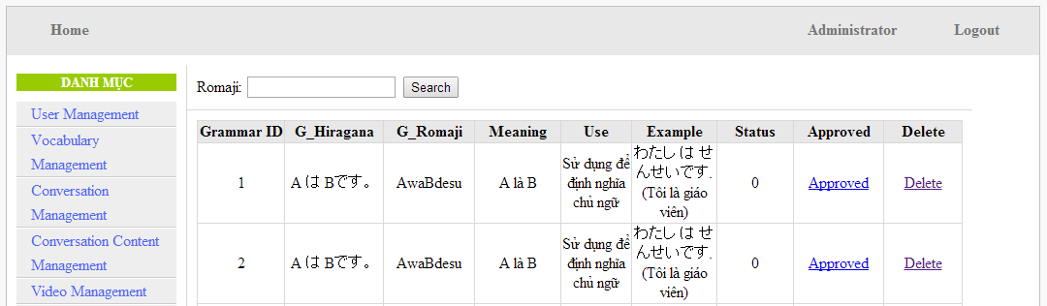

Figure 14.2: Contribute grammar’ screen:

Table 14.2: Contribute grammar’ screen description:

|  |  |  |  |  |  |  |
| --- | --- | --- | --- | --- | --- | --- |
| No | Field name | Type | Require | Mandatory | Max-Length | Description |
| 1 | Romaji | Text | Text | Y | 100 | Admin input to search |
| 2 | Approved | Button | Click | N |  | Admin click to approved contribute |
| 3 | Delete | Button | Click | N |  | Admin click delete contribute |

1. Contribute vocabulary screen:

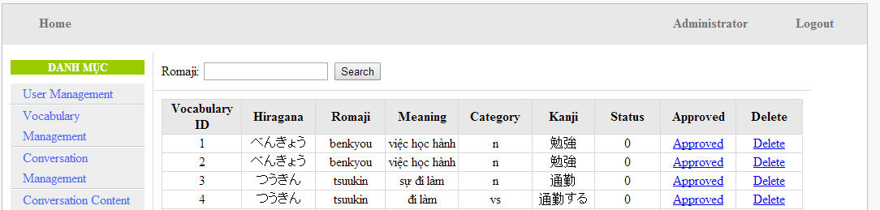

Figure 14.3: Contribute vocabulary screen:

Table 14.3: Contribute vocabulary screen description:

|  |  |  |  |  |  |  |
| --- | --- | --- | --- | --- | --- | --- |
| No | Field name | Type | Require | Mandatory | Max-Length | Description |
| 1 | Romaji | Text | Text | Y | 100 | Admin input to search |
| 2 | Approved | Button | Click | N |  | Admin click to approved contribute |
| 3 | Delete | Button | Click | N |  | Admin click delete contribute |

|  |  |  |  |  |
| --- | --- | --- | --- | --- |
| **UC0052 - Specification** | | | | |
| **Use-case No.** | <UC0052> | **Use-case Version** | | <1.0> |
| **Use-case Name** | Search contribute content | | | |
| **Author** | Minh PT | | | |
| **Date** | 09/06/2014 | **Priority** | <High > | |
| **Actor:**  Admin  **Summary:**  When administrator wants to search contribute content include kanji, grammar, vocabulary in database. User input data then click “Search” button.  **Triggers**  Click on “Contribute Kanji Management ” or “Contribute Grammar Management ” or “Contribute Vocabulary Management ” tab, input data in the right text box then click “Search” button  **Preconditions:**   * Website is available * User has to login as Administrator * User has to input data in search area   **Post Conditions:**  Display detail information of contribute content  **Main Success Scenario:**   |  |  |  | | --- | --- | --- | | **Step** | **User** | **System** | | 1 | Have logged into system as an admin |  | | 2 | Click on “Contribute Kanji Management ” or “Contribute Grammar Management ” or “Contribute Vocabulary Management ” tab | Displays criteria search screen | | 3 | Fill information that they want to find into text box then click “Search” button | Displays search result as a table with these elements:   1. Kanji:  - Kanji ID - K_Kanji - K_Hanviet - K_Onyomi - K_Kunyoumi - K_Meaning - K_level - K_Status - Approved - Delete 2. Grammar: - Grammar ID - G_Hiragana -G_ Romaji - Meaning - Use - Example - Status - Approved - Delete 3. Vocabulary: - Vocabulary ID - Hiragana - Romaji - Meaning - Category - Kanji - Status - Approved - Delete |     **Alternative Scenario:**   |  |  |  | | --- | --- | --- | | **At Step** | **User** | **System** | | 3 | Fill information that they want to find into these fields then click on another link | Switch to selected page |   **Exceptions:**   |  |  |  | | --- | --- | --- | | **At Step** | **User** | **System** | | 3 | Fill information that they want to find (that do not exited in database) into these fields then click “Search” button | Return Error message to inform that listening article cannot be found | | | | | |

##### UC053 <Contact’s content Management>: Approve contribute content

Approve contribute content screen:

1. Approve contribute kanji screen:

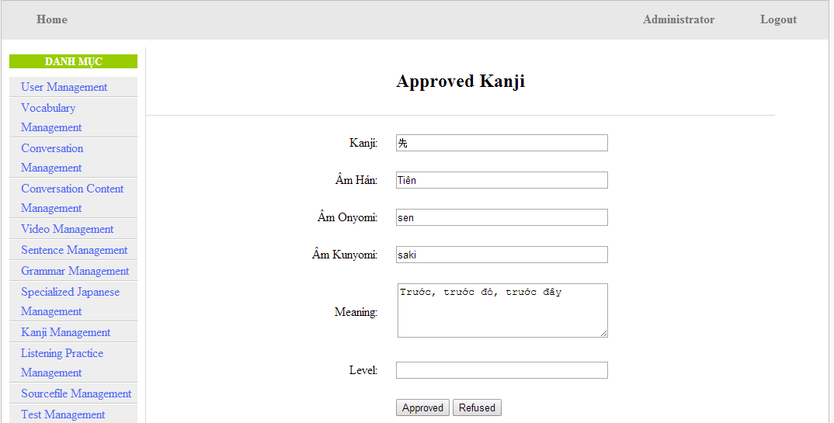

Figure 15.1: Approved kanji’s screen

Table 15.1: Approved kanji’s screen description

|  |  |  |  |  |  |  |  |
| --- | --- | --- | --- | --- | --- | --- | --- |
| No | Field name | File name in Vietnamese | Type | Require | Mandatory | Max-Length | Description |
| 1 | Kanji | Kanji | Text | Text | Y | 10 | Admin input kanji |
| 2 | AmHan | Âm hán | Text | Text | N | 50 | Admin input to the field |
| 3 | Onyomi | Âm Onyomi | Text | Text | Y | 100 | Admin input onyomi |
| 4 | Kunyomi | Âm kunyomi | Text | Text | Y | 100 | Admin input kunyomi |
| 5 | Meaning | Nghĩa | Text | Text | Y | 200 | Admin input meaning |
| 6 | Level | Level | Text | Text | Y | 10 | Admin choose the level |
| 7 | Approved | Approved | Button | Click | N |  | Admin click to approved contribute |
| 8 | Refuse | Refuse | Button | Click | N |  | Admin click to refuse contribute |

1. Approve contribute grammar screen:

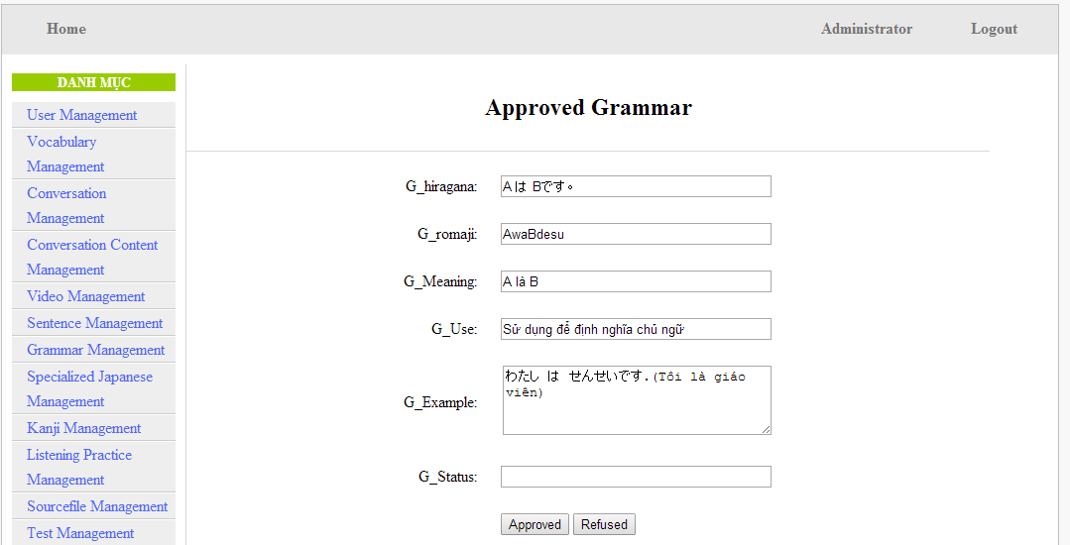

Figure 15.2: Approved grammar screen

Table 15.2: Approved grammar’s screen description:

|  |  |  |  |  |  |  |
| --- | --- | --- | --- | --- | --- | --- |
| No | Field name | Type | Require | Mandatory | Max-Length | Description |
| 1 | Hiragana | Text | Text | Y | 200 | Admin input hiragana |
| 2 | Romaji | Text | Text | N | 200 | Admin input romaji |
| 3 | Meaning | Text | Text | Y | 200 | Admin input meaning |
| 4 | Use | Text | Text | Y | 100 | Admin input kunyomi |
| 5 | Example | Text | Text | Y | 200 | Admin input meaning |
| 6 | Level | Text | Text | Y | 10 | Admin input level of grammar |
| 7 | Approved | Button | Click | N |  | Admin click to approved contribute |
| 8 | Refuse | Button | Click | N |  | Admin click to refuse contribute |

1. Approve contribute vocabulary screen:

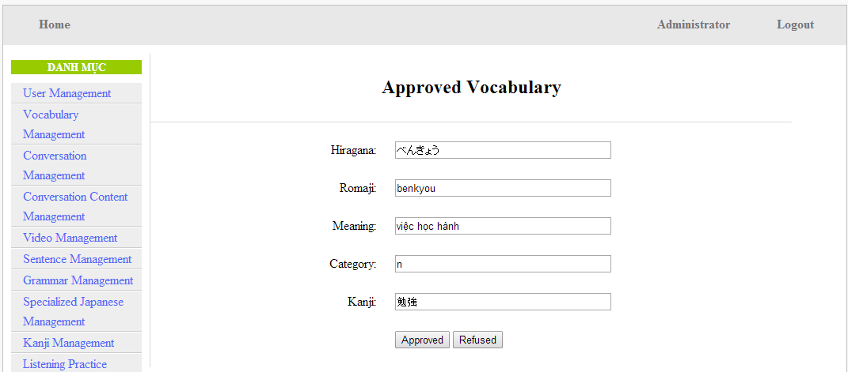

Table 15.3: Approved vocabulary

Table 15.3: Approved vocabulary’s screen description:

|  |  |  |  |  |  |  |
| --- | --- | --- | --- | --- | --- | --- |
| No | Field name | Type | Require | Mandatory | Max-Length | Description |
| 1 | Hiragana | Text | Text | Y | 200 | Admin input hiragana |
| 2 | Romaji | Text | Text | N | 200 | Admin input romaji |
| 3 | Meaning | Text | Text | Y | 500 | Admin input meaning |
| 4 | Category | Text | Text | Y | 10 | Admin choose category |
| 5 | Kanji | Text | Text | Y | 10 | Admin input kanji |
| 6 | Approved | Button | Click | N |  | Admin click to approved contribute |
| 7 | Refuse | Button | Click | N |  | Admin click to refuse contribute |

|  |  |  |  |  |
| --- | --- | --- | --- | --- |
| **UC0053 - Specification** | | | | |
| **Use-case No.** | <UC0053> | **Use-case Version** | | <1.0> |
| **Use-case Name** | Approve contribute content | | | |
| **Author** | Minh PT | | | |
| **Date** | 09/06/2014 | **Priority** | <High > | |
| **Actor:**  Admin  **Summary:**  When administrator wants to approve contribute content include kanji, grammar, vocabulary in database. User click on link corresponding with kanji, grammar, vocabulary  **Triggers**  Click on “Contribute Kanji Management” or “Contribute Grammar Management” or “Contribute Vocabulary Management” tab, input data in the right text box then click “Search” button. Click on link corresponding with kanji, grammar, vocabulary which want to approve to database  **Preconditions:**   * Website is available * User has to login as Administrator * All mandatory fields have been filled * All input data must be valid and have not existed in system   **Post Conditions:**  Display detail information of contribute content  **Main Success Scenario:**   |  |  |  | | --- | --- | --- | | **Step** | **User** | **System** | | 1 | Have logged into system as an admin |  | | 2 | Click on “Contribute Kanji Management ” or “Contribute Grammar Management ” or “Contribute Vocabulary Management ” tab | Displays criteria search screen | | 3 | Fill information that they want to find into text box then click “Search” button | Displays search result | | 4 | Click “Approved” link corresponding want to update into database | Display Approve kanji screen with these elements:   1. Kanji - Kanji - Âm hán - Âm Onyomi - Âm Kunyoumi - Meaning - level - Approved - Refused 2. Grammar: - G_Hiragana - G_ Romaji - G_Meaning - G_Use - G_Example - G_Status - Approved - Refused 3. Vocabulary: - Hiragana - Romaji - Meaning - Category - Kanji - Approved - Refused | | 5 | Edit or add more information |  | | 6 | Click “Approved” button | The system validates the input data and then save data into database | | 6 | Click “Refused” button | The system cancel approve data |     **Alternative Scenario:**   |  |  |  | | --- | --- | --- | | **At Step** | **User** | **System** | | 5 | Fill information then click on another link | Switch to selected page |   **Exceptions:**   |  |  |  | | --- | --- | --- | | **At Step** | **User** | **System** | | 5 | Fill information that exited in database into fields then click “Approved” button | Return Error message to inform that data is exiting in database |   **Reference:**  UC0052 - < Contact’s content Management > Search contribute content | | | | |

##### UC0054: < Contact’s content Management > Delete contribute content

|  |  |  |  |  |
| --- | --- | --- | --- | --- |
| **UC0054 - Specification** | | | | |
| **Use-case No.** | <UC0054> | **Use-case Version** | | <1.0> |
| **Use-case Name** | Delete contribute content | | | |
| **Author** | Minh PT | | | |
| **Date** | 09/06/2014 | **Priority** | <High > | |
| **Actor:**  Admin  **Summary:**  When Administrator wants to delete a contribute content. Admin will search that content then click “Delete” link corresponding.  **Triggers**  User must click on “Contribute Kanji Management” or “Contribute Grammar Management” or “Contribute Vocabulary Management” tab then search for the contribute content. User click on “Delete” link corresponding with kanji, grammar, vocabulary which want to delete.  **Preconditions:**   * Website is available * User has to login as Administrator   **Post Conditions:**  Kanji, grammar, vocabulary have been deleted from list successfully  **Main Success Scenario:**   |  |  |  | | --- | --- | --- | | **Step** | **User** | **System** | | 1 | Have logged into system as an admin |  | | 2 | Click on “Contribute Kanji Management ” or “Contribute Grammar Management ” or “Contribute Vocabulary Management ” tab then search for the kanji, grammar, vocabulary that user want to delete | Displays search result as a table | | 3 | Click on “Delete” link corresponding with kanji, grammar, vocabulary | Remove that kanji, grammar, vocabulary from list |   **Reference:** UC0052 - < Contact’s content Management > Search contribute content | | | | |
|  | | | | |

### Contributed opinion management

#### Use case diagram

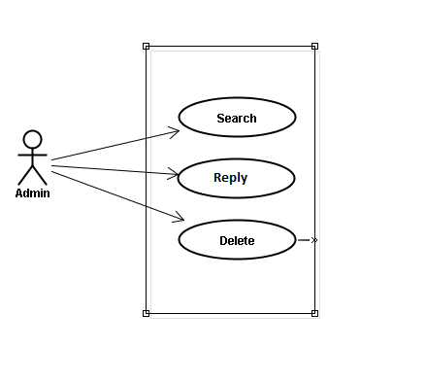

#### Use case specifications

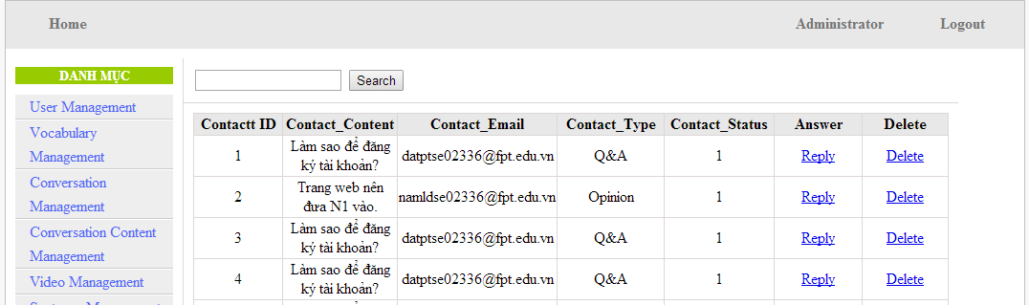

Screen Description: This is Opinion/Q&A Management screen. When admin want to reply question from member, admin have to log in. At here, Admin can manage by search question, reply question and delete question

##### UC055 <Opinion/Q&A Management>: Search question

Search question screen:



Figure 16.1: Contribute opinion management’s screen

Table 16.1: Contribute opinion management’s screen description

|  |  |  |  |  |  |  |
| --- | --- | --- | --- | --- | --- | --- |
| No | Field name | Type | Require | Mandatory | Max-Length | Description |
| 1 | Reply | Button | Click | N |  | Admin click reply the question |
| 2 | Delete | Button | Click | N |  | Admin click delete question |

|  |  |  |  |  |
| --- | --- | --- | --- | --- |
| **UC0055 - Specification** | | | | |
| **Use-case No.** | <UC0055> | **Use-case Version** | | <1.0> |
| **Use-case Name** | Search question | | | |
| **Author** | Minh PT | | | |
| **Date** | 09/06/2014 | **Priority** | <High > | |
| **Actor:**  Admin  **Summary:**  When administrator wants to search question from member. User input data then click “Search” button.  **Triggers**  Click on “Contact Management ” tab, input data in the right text box then click “Search” button  **Preconditions:**   * Website is available * User has to login as Administrator * User has to input data in search area   **Post Conditions:**  Display detail information of question  **Main Success Scenario:**   |  |  |  | | --- | --- | --- | | **Step** | **User** | **System** | | 1 | Have logged into system as an admin |  | | 2 | Click on “Contact Management ” tab | Displays criteria search screen | | 3 | Fill information that they want to find into text box then click “Search” button | Displays search result as a table with these elements:   * Contact ID * Contact_Content * Contact_Email * Contact_Type * Contect_Status * Answer * Delete |     **Alternative Scenario:**   |  |  |  | | --- | --- | --- | | **At Step** | **User** | **System** | | 3 | Fill information that they want to find into these fields then click on another link | Switch to selected page |   **Exceptions:**   |  |  |  | | --- | --- | --- | | **At Step** | **User** | **System** | | 3 | Fill information that they want to find (that do not exited in database) into these fields then click “Search” button | Return Error message to inform that cannot be found | | | | | |

##### UC056 <Opinion/Q&A Management>: Reply question

Reply question screen:

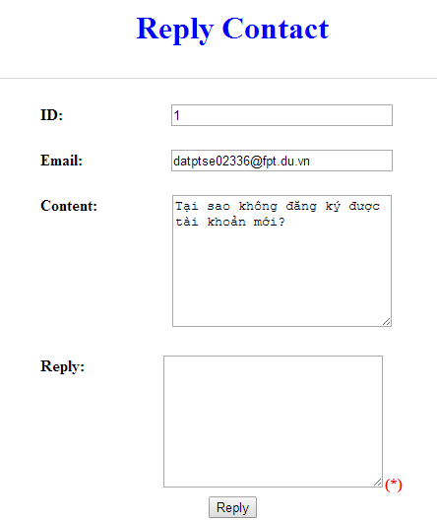

Figure 16.2 : Reply contact

Table 16.2: Reply contact’s screen description:

|  |  |  |  |  |  |  |
| --- | --- | --- | --- | --- | --- | --- |
| No | Field name | Type | Require | Mandatory | Max-Length | Description |
| 1 | ID |  |  |  |  | ID of admin’s account |
| 2 | Email |  |  |  |  | Email of admin’s account |
| 3 | Content |  |  |  |  | Question |
| 4 | Reply | Text | Text | Y |  | Admin input reply of question |
| 5 | Send | Button | Click | N |  | Admin click send reply question |

|  |  |  |  |  |
| --- | --- | --- | --- | --- |
| **UC0056 - Specification** | | | | |
| **Use-case No.** | <UC0056> | **Use-case Version** | | <1.0> |
| **Use-case Name** | Search question | | | |
| **Author** | Minh PT | | | |
| **Date** | 09/06/2014 | **Priority** | <High > | |
| **Actor:**  Admin  **Summary:**  When administrator wants to reply question from member.  **Triggers**  Click on “Opinion/Q&A Management ” tab, User search question then click “Reply” link corresponding  **Preconditions:**   * Website is available * User has to login as Administrator * User has to input answer   **Post Conditions:**  Answer be sent to user  **Main Success Scenario:**   |  |  |  | | --- | --- | --- | | **Step** | **User** | **System** | | 1 | Have logged into system as an admin |  | | 2 | Click on “Opinion/Q&A Management ” tab | Displays criteria search screen | | 3 | Click “Reply” link corresponding | Displays Reply screen with these elements:   * Contact_Content * Contact_Email * Answer | | 4 | Input the answer |  | | 5 | Click “Reply” button | The answer of question will be sent to member |     **Alternative Scenario:**   |  |  |  | | --- | --- | --- | | **At Step** | **User** | **System** | | 4 | Input answer then click on another link | Switch to selected page |   **Exceptions:**   |  |  |  | | --- | --- | --- | | **At Step** | **User** | **System** | |  |  |  | |  |  |  |   **Reference:**  UC0055 - < Opinion/Q&A Management > Search question | | | | |

## Non-functional Specification

### Reliability

* Mean time between failures: The mean time between each failure is expected to be about 480 hours of using.
* Mean time to repair: Immediately when Administrator finds out problem or website is attacked/hacked by someone. Average 1 day.
* The maximum bugs per function are 2 bugs/a function when user uses software within 2 months. The average number of bugs in the software during system testing is about to be around 1 bugs/1000 LOC.
* The database must be backed up daily and can be recovered if necessary

### Performance Requirements

#### Availability

The application must be available 95% of time. Users can access to it everywhere from their

Web browser with internet connection.

#### Response time

In term of response time, waiting time of processing will be 2 to 5 seconds; time to process any functions will not exceed 7 seconds.

### User Interface

● **Color:** The background color will be white and blue in default. The color of text will

be black or white.

● **Text:** All texts bases on Helvetica style and title or label will use upper case with the

first letter.

### Maintainability

* **Coding standards and naming conventions**
  + Output of the project must include coding standards and naming conventions documentations. Implementation code must be easy to maintain.
  + All code must be clearly commented, including class, method documentations.
  + If some components are reused, the documentations of those components must also be included.
* **Design**
  + The design of the system must be loosely coupled that chances on some module will not affect others.
* **Logging**
  + All the errors should be logged, supporting for bug fixing and maintenance.
  + All strange or sensitive situations should also be logged.

### Usability

Usability Requirements support the following from the perspective of its primary users:

● **Efficiency of use:** user can complete each function in less than 12 actions

● **Intuitiveness:** all help/error messages are simple to understand; user can know exactly how to do each feature after one time using it.

### Security Requirements

In order to avoid unwanted access by strangers, the security implemented in various ways:

* **User layer**: Each function must be distributed system access and manipulate the individual parts. To edit information, user must declare their username and password before the operation. Functions will be show after users login dependencies user’s role and permission of each user.
* **Manage Data Layer**: Only Administrator can modify database system.
* **Stored Data**: All data about information of user, tested, etc.. will be saved in My SQL Server, and be easy for data classification or backup..

### Hardware/Software Requirements

● **Hardware requirement:** PC/Laptop (window 7, window 8, window XP…)

● **Software requirements:** Web browser (Chrome, Firefox, IE…) with internet connection